POSITION DESCRIPTION | 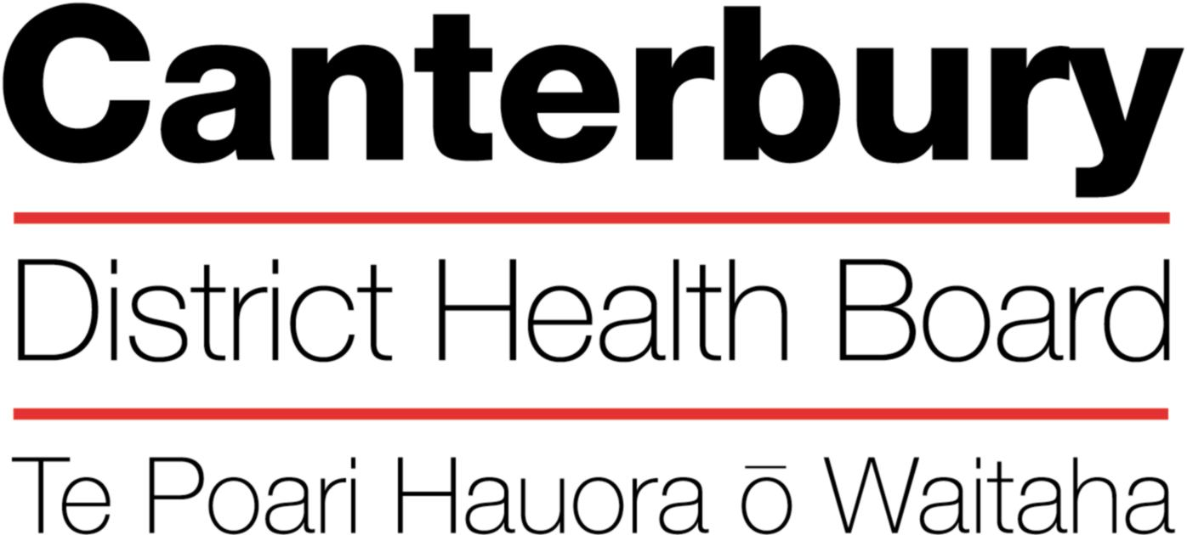

March 2018
This Position Description is a guide and will vary from time to time and
between services and/or units to meet changing service needs

The Canterbury District Health Board is committed to the principles of the Treaty of Waitangi and the overarching objectives of the New Zealand health and disability strategies.

Organisational Vision

The Canterbury District Health Board’s vision is to promote, enhance and facilitate the health and wellbeing of the people of the Canterbury District.

Organisational Values
The Canterbury DHB is committed to being an excellent and caring funder / provider of health and hospital services. Integral to the achieving of our vision, goals and objectives of the DHB are the values of the organisation:

Care & respect for others

Integrity in all we do

Responsibility for outcomes

POSITION TITLE: |  | Administrator
REPORTS TO (Title): |  | Service manager
REPORTS ON A DAILY BASIS TO: |  | Administrative Co-ordinator
PRINCIPAL OBJECTIVE

To provide transcription services and administrative support to assist the Women’s Health Service in meeting the objectives and targets of the service.
FUNCTIONAL RELATIONSHIPS:

INTERNALLY:
1 | Administrative Co-ordinator / Administration Team members
2 | Clinicians
3 | Nurses
4 | Service Manager
5 | All CDHB staff
EXTERNALLY:
1 | Patients and their families
2 | General Practitioners and their staff
3 | Staff from other District Health Boards and the Ministry of Health
The Administrator will be successful when:
- Effectively communicate with all internal and external clients

- Dictated letters are completed within set timeframes (usually 3-5 days)
- Written work is presented and accurate.
- All letters and outgoing correspondence is processed and distributed within 24 hours of sign-off by clinicians
- All enquires and requests from DHB staff, external agencies, general practitioners, patients and other members of the public are responded to promptly and appropriate action taken.
- Effective working relationships are maintained with staff from other departments within Christchurch, Ashburton and Burwood hospitals.
- Good public relations and communication skills are practised at all times.

- Patient flow is streamlined
Time is managed well to support prioritisation and completion of competing demands.
- Patients and visitors to the department are greeted warmly and directed to the appropriate area.
- Patient management system is checked for patient demographics and updated as appropriate.
- All information required by CDHB Management is collected as per agreed protocols and business rules.
- Patients who are clearly unwell or infirm are referred immediately to nursing staff.
- Standardised booking processes are followed contributing to a high performing booking system
Outpatient Bookings
- Referrals are managed as per CDHB Elective Services Guidelines.
- All data is entered into the patient management system accurately and in a timely manner.
- All urgent referrals are allocated to the earliest possible clinic.
- Appointments are made and appointment letters are sent in advance in accordance with the current policy.
- Patient appointments are monitored to keep within Departmental and MOH guidelines.
- Clinical opinion is obtained regarding any re-categorisation queries from General Practitioners or other referral sources.
- Vacant appointment spaces are filled to ensure an efficient flow of patients through all clinics.
- Cancellations are kept to a minimum by liaising with medical staff over conference and other leave commitments.
- Patient documents/results are available before the clinic commences.
- Post-clinic tasks are followed up and completed including coding and follow up/discharge of non-attenders (DNA)
- Interpreter service is arranged as required.

- Coding and data entry of relevant patient information is completed

- All CDHB coding and patient management systems updated for accurate reporting and service planning.

- Undertake other duties and projects as reasonably directed by the Team Leader from time to time
- Assistance with the overall service provision as workload determines.
- Additional duties are carried out in the best interest of the service and in a competent and efficient manner.
- Front of house duties undertaken as directed by the Team Leader (including managing the arrival and departure of patients).

- Communication
- Positive and professional behaviours in all relationships
- Communication is clear, open, accurate and responsible
- Confidentiality is maintained
- Proactively seeks feedback
- Minutes that are recorded and circulated are read and actioned appropriately
- Contribute to a supportive environment in order to create a high functioning service
- Quality
- A quality service is provided by taking an active role in quality activities and identifying areas of improvement
- Be familiar with and apply the appropriate organisational and divisional policies and procedures
- Health and Safety
Maintain a high quality, safe and secure work environment by following relevant Canterbury DHB and divisional policies, protocols and standards.
All Canterbury DHB safe work procedures and instructions are observed
- Own safety and that of others is ensured
- All hazards or potential hazards are immediately reported
- Protective equipment is used when appropriate and protective clothing is worn when required
- Unsafe work situations are made safe or, if they cannot, the supervisor or manager is informed
- Workplace hazards and employees health is monitored
- All accidents or incidents are promptly reported to your manager
- The Canterbury DHB’s rehabilitation plan, to ensure an early and durable return to work, is activated when required
- Advice is sought from your manager if you are unsure of any work practice

PERSON SPECIFICATION:

- Be able to relate to patients and their families in a courteous and helpful manner.
- Be able to perform under periods of pressure.
- Ability to maintain confidentiality.
- Actively seeks feedback on opportunities to improve
- Be well groomed and appropriately dressed at all times.
- Ability to work together in a truthful and helpful manner.
- Ability to work smarter by being innovative and proactive.
- Accepts responsibility for actions.

Qualifications & Experience
Essential:
- Excellent keyboard skills (typing speed of 50-70 wpm)
- Excellent customer service skills – people focused
- Technically savvy – quick at picking up new applications/systems
- Excellent organisational, time management and problem solving skills
- Ability to achieve accuracy and maintain attention to detail
- Ability to meet deadlines and work unsupervised
- A team player
- Intermediate user in the Microsoft suite of products e.g. Word, Outlook, Excel
- High level of written and verbal communication skills
- Demonstrated perceptiveness and a proactive approach in an administrator role.

Desired:
- Broad administrative experience in a health related field
- Knowledge of medical terminology
- Familiarity with the public hospital system (including the patient management system)
- Awareness of people of differing cultural backgrounds.

The intent of this position description is to provide a representative summary of the major duties and responsibilities performed in this job classification. Employees may be requested to perform job related tasks other than those specified

