POSITION DESCRIPTION | 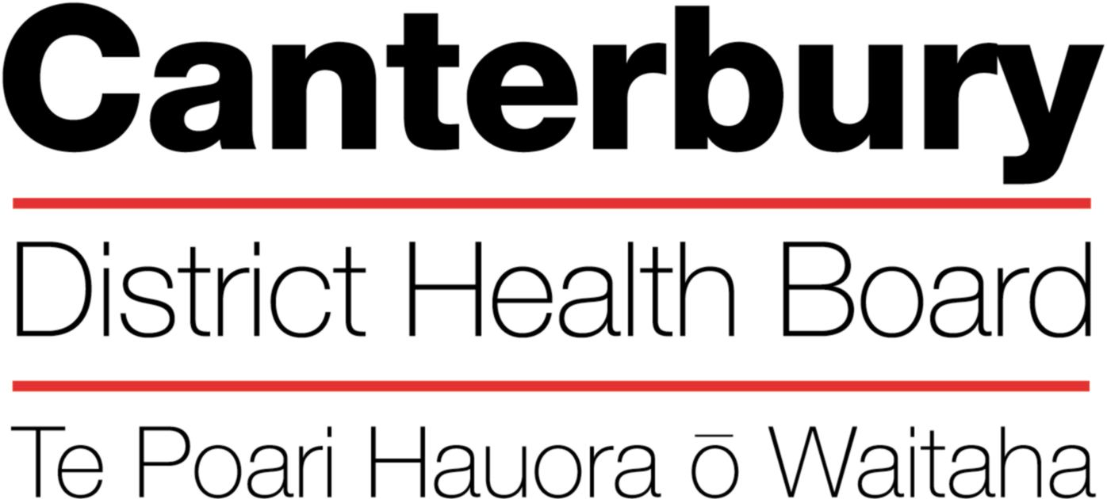

October 2018
This Position Description is a guide and will vary from time to time and between services and/or units to meet changing service needs

The Canterbury District Health Board is committed to the principles of the Treaty of Waitangi and the overarching objectives of the New Zealand health and disability strategies.

Organisational Vision

The Canterbury District Health Board’s vision is to promote, enhance and facilitate the health and wellbeing of the people of the Canterbury District.

Organisational Values
The Canterbury DHB is committed to being an excellent and caring funder / provider of health and hospital services. Integral to the achieving of our vision, goals and objectives of the DHB are the values of the organisation:

Care & respect for others

Integrity in all we do

Responsibility for outcomes

POSITION TITLE: |  | Administrator
REPORTS TO (Title): |  | Service Manager – Forensic Pathology and Mortuary Service
REPORTS ON A DAILY BASIS TO: |  | Service Manager - Forensic Pathology and Mortuary Service
PRINCIPAL OBJECTIVE

To provide secretarial services, administrative support and project work to assist the Forensic Pathology and Mortuary Service in meeting the objectives and targets of the service.
FUNCTIONAL RELATIONSHIPS:

INTERNALLY:
1 | Service Manager
2 | Clinicians
3 | Mortuary Technicians
4 | Canterbury Health Laboratory Staff (CHL)
5 | All CDHB staff
EXTERNALLY:
1 | Coroners National Initial Investigation Office (NIIO)
2 | The Institute of Environmental Science and Research (ESR)
3 | Whanau of Tūpāpaku (deceased)
4 | Police
5 | Coronial Offices nationwide
6 | Ministry of Justice
7 | Staff from other District Health Boards
The Administrator will be successful when:
- Effectively communicate with all internal and external clients

- Written work is well presented and accurate.
- Letters, reports are completed within set timeframes.
- All enquires and requests from DHB staff, NIIO, Police and other external agencies are responded to promptly and appropriate action taken.
- Effective working relationships are maintained with staff from other departments within CDHB mortuary services and across the South Island.
- Good public relations and communication skills are practised at all times.
- A broad knowledge of coronial jurisdiction and practice is developed and maintained.
- Data entry of relevant information is completed

- All CDHB patient management systems are updated for accurate reporting and service planning.
- All data is entered into a secure Forensic data base accurately and in a timely manner.
- Follow up as required on reporting of test results for Tūpāpaku.
- Undertake other duties and projects as reasonably directed by the Service Manager Leader from time to time
- Assistance with the overall service provision as workload determines.
- Additional duties are carried out in the best interest of the service and in a competent, enthusiastic and efficient manner.
- Communication
- Positive and professional behaviours in all relationships.
- Communication is clear, open, accurate and responsible.
- Confidentiality is maintained.
- Proactively seeks feedback.
- Minutes that are recorded and circulated are read and actioned appropriately.
- Contribute to a supportive environment in order to create a high functioning service.
- Quality
- A quality service is provided by taking an active role in quality activities and identifying areas of improvement.
- Be familiar with and apply the appropriate organisational and divisional policies and procedures.
- Assist in ensuring that the Mortuary continues to meet IANZ standards.
- Health and Safety
Maintain a high quality, safe and secure work environment by following relevant Canterbury DHB and divisional policies, protocols and standards.
All Canterbury DHB safe work procedures and instructions are observed
- Own safety and that of others is ensured
- All hazards or potential hazards are immediately reported
- Protective equipment is used when appropriate and protective clothing is worn when required
- Unsafe work situations are made safe or, if they cannot, the supervisor or manager is informed
- Workplace hazards and employees health is monitored
- All accidents or incidents are promptly reported to your manager
- The Canterbury DHB’s rehabilitation plan, to ensure an early and durable return to work, is activated when required
- Advice is sought from your manager if you are unsure of any work practice

PERSON SPECIFICATION:

Leadership Capabilities (as per the Leadership Capability Framework)
Dimension | Description
Display self-knowledge | Actively seeks feedback on opportunities to improve
Builds relationships and mobilise support | Communicate and influence others
Communicate a vision and sense of purpose | Inspire a sense of purpose and commitment
Stimulate innovation and create immediate wins | Model and cultivate innovation and creative practices
Consolidate and continuously improve on strategic change | Identify change imperative and opportunities
Fosters a positive culture | Embrace difference and diversity
Qualifications & Experience
Essential:
- Excellent keyboard skills (typing speed of 50-70 wpm)
- Technically savvy – quick at picking up new applications/systems
- Excellent customer service skills – people focused
- Excellent organisational, time management and problem solving skills
- Interest and skill in project management
- Ability to achieve accuracy and maintain attention to detail
- Ability to meet deadlines and work unsupervised
- Intermediate user in the Microsoft suite of products e.g. Word, Outlook, Excel
- High level of written and verbal communication skills
- Demonstrated perceptiveness and a proactive approach in an administrator role.
- A team player

Desired:
  - Administrative experience in a health or social sector related field
  - Knowledge of medical terminology
  - Awareness of people of differing cultural backgrounds particularly when dealing with loss and grief

The intent of this position description is to provide a representative summary of the major duties and responsibilities performed in this job classification. Employees may be requested to perform job related tasks other than those specified

