POSITION DESCRIPTION | 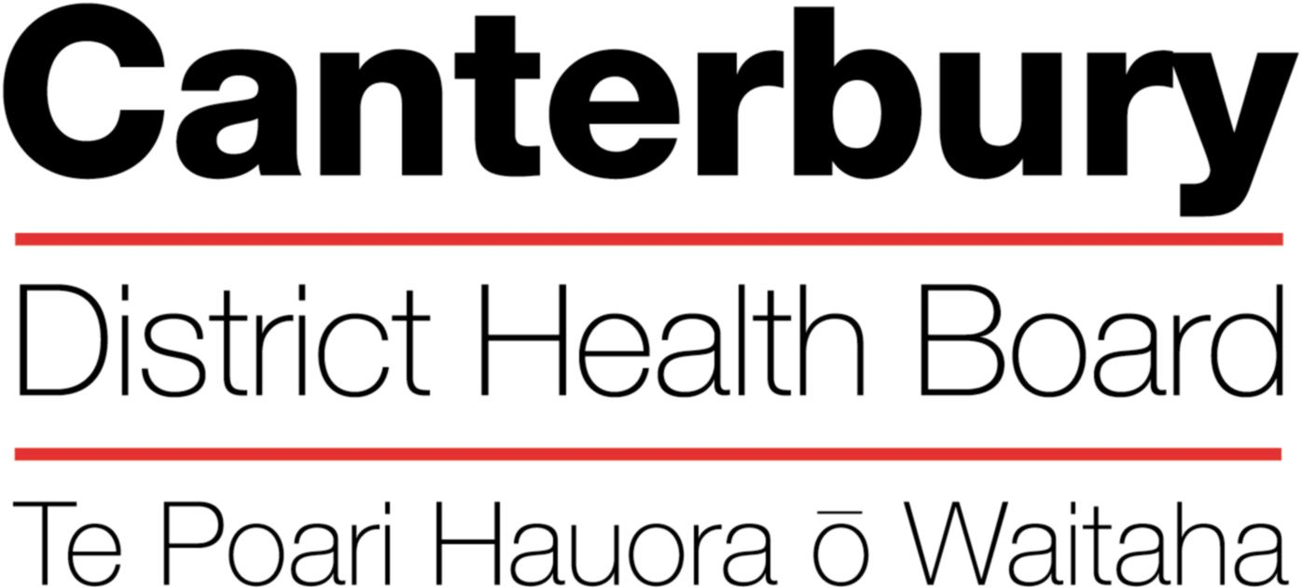

August 2010
This Position Description is a guide and will vary from time to time and
between services and/or units to meet changing service needs

The Canterbury District Health Board is committed to the principles of the Treaty of Waitangi and the overarching objectives of the New Zealand health and disability strategies.

Organisational Vision
The CDHB’s vision is to improve the health and well being of the people living in Canterbury.

Organisational Values
- Care & respect for others
- Integrity in all we do
- Responsibility for outcomes
POSITION TITLE: |  |  |  | Medical Oncologist
REPORTS TO (Title): |  |  |  | Clinical Director of Canterbury Regional Cancer and Blood Service (Cluster Chair)
REPORTS ON A DAILY BASIS TO: |  |  |  | Clinical Director of Medical Oncology Services
PRINCIPAL OBJECTIVES

- To plan and manage assessment and treatment of patients referred to Canterbury District Health Board, Oncology Service.
- To provide specialist oncology inpatient, outpatient and day patient services for patients referred to Canterbury District Health Board, Oncology Service.
FUNCTIONAL RELATIONSHIPS:
(Who are the customer/consumers/patients)
INTERNALLY:
1 | Patients and patient families
2 | Oncology Service inpatient and outpatient nursing, pharmacy, radiation therapy administrative and allied health staff
3 | SMO and RMO staff within Christchurch Hospital, including surgical specialists, radiologists, pathologists, physicians, specialist nurses
4 | Medical students, other health professionals, students
EXTERNALLY:
1 |  | University of Otago (Christchurch School of Medicine) Staff
2 |  | General Practitioners
3 |  | Specialists in Private Practice, or in other DHBs.
4 |  | Relevant Patient Support Agencies
5 |  | Regional clinicians and Laboratories – Ashburton, Greymouth, Nelson/Blenheim, Timaru
6  7 |  | Southern Cancer Network

KEY PERFORMANCE OBJECTIVES:

Task | To provide medical oncology – related diagnostic, investigative, treatment and consultative services
Expected Result | - In collaboration with the other SMOs, assume responsibility for treating a portfolio of specific cancer types with this reflected in MDT attendance and in main CPD activities  - Holds regular outpatient clinics to see new patients, patients on treatment and follow up as required  - Take responsibility for tasks delegated to other members of the care team  - Provide outreach clinic services by telehealth and visiting peripheral centres as required  - Provide a consultative service to wards as required  - Participate in planned patient discharge and interdisciplinary meetings  - In conjunction with other medical oncologists provide rostered continuous cover for inpatient care and acute calls
Task | To provide high quality oncologic care
Expected Result | - To maintain an up-to-date knowledge of best medical oncology practice  - To see urgent new patients as clinically required within an overall workload managed by the service  - To provide treatment in a timely manner, as resources allow  - To produce accurate, timely and clear clinical notes and communications  - To facilitate treatment in accordance with CDHB value “in people’s homes and communities” where this is possible  - To reduce hospital admission and length of stay  - To facilitate seamless transitions for patients between parts of the health service at different times in the “cancer journey”
Task | To provide training and educational programmes as required
Expected Result | - Participate in service development and clinical leadership roles for the Oncology Service and CDHB as required  - Meet with nursing and allied health professional Oncology Service staff as required.  - Maintain appropriate College of Physicians certification to supervise basic and advanced trainees  - Participate in informal and didactic teaching sessions for medical, nursing and wider oncology staff  - Participate in Oncology Service CPE and hospital CME programmes  - Assisting agencies and voluntary support bodies to have a sound understanding of clinical speciality practice and services available.
Task | To participate in the postgraduate and undergraduate training programmes of the Christchurch School of Medicine and relevant training institutions.
Expected Result | - Provide postgraduate and undergraduate medical training including medical student teaching and hosting medical students in clinics and on ward

Task | To maintain clinical competence through participation in clinical and/or laboratory based research activities or in recertification programmes of appropriate college and medical council.
Expected Result | - Maintain appropriate Medical Council certification and participate in College of Physicians CPD programme  - Participate in oncology research programme as principle or co-investigator for external studies
Task | Continuous quality improvement
Expected Result | - Active participation in oncology and CDHB quality activities  - Initiate clinical research projects and clinical audit  - Review and implement international advances in Oncology management  - Attend conferences and workshops, nationally and internationally, relevant to work practice  - Initiate relevant basic research projects in collaboration with other departments  - Initiate and facilitate collaborative clinical trials, both national and international with particular emphasis on randomised controlled trials  - Contribute to the development of an integrated regional oncology service in Canterbury and elsewhere in the South Island.
Task | To undertake other duties as reasonably requested by the Clinical Director or General Manager, Medical / Surgical, Christchurch Hospital from time to time.
Task | To support the aims and objectives of Canterbury District health Board as embodied in the mission statement.

HEALTH & SAFETY:

- Observe all Canterbury DHB safe work procedures and instructions
- Ensure your own safety and that of others
- Report any hazards or potential hazard immediately
- Use all protective equipment and wear protective clothing provided
- Make unsafe work situations safe or, if they cannot, inform your supervisor or manager
- Co-operate with the monitoring of workplace hazards and employees health
- Ensure that all accidents or incidents are promptly reported to your manager
- Report early any pain or discomfort
- Take an active role in the Canterbury DHB’s rehabilitation plan, to ensure an early and durable return to work
- Seek advice from your manager if you are unsure of any work practice

QUALITY:
Every staff member within CDHB is responsible for ensuring a quality service is provided in there area of expertise. All staff are to be involved in quality activities and should identify areas of improvement. All staff are to be familiar with and apply the appropriate organisational and divisional policies and procedures.

The intent of this position description is to provide a representative summary of the major duties and responsibilities performed by staff in this job classification. Staff members may be requested to perform job-related tasks other than those specified.

QUALIFICATIONS & EXPERIENCE:
Essential
- Specialist qualification in medical oncology
- Qualifications recognised for specialist registration with the New Zealand Medical Council
- Current Annual Practising Certificate

Professional memberships required
- FRACP

Other skills required
- Be able to work under pressure and prioritise a heavy clinical workload
- Have excellent written and communication skills
- Demonstrate a team approach to work and a collaborative working relationship with management

