POSITION DESCRIPTION | 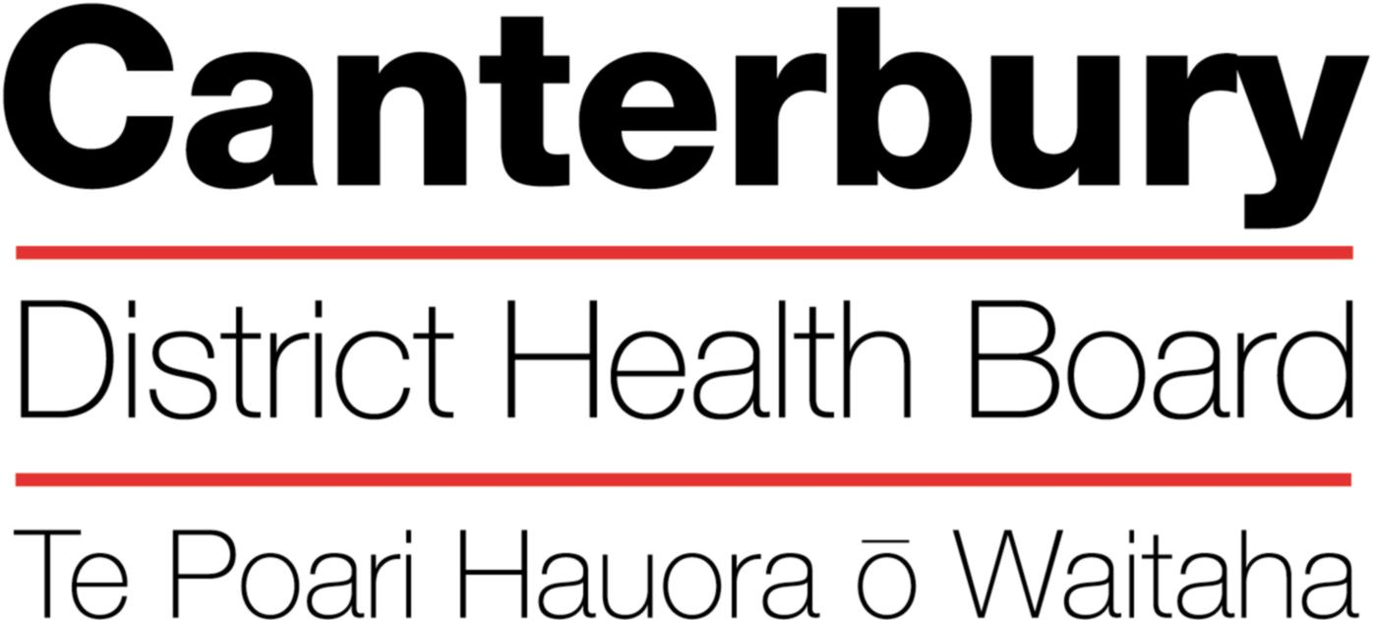

This Position Description is a guide and will vary from time to time and
between services and/or units to meet changing service needs
January 2022

The Canterbury District Health Board is committed to the principles of the Treaty of Waitangi and the overarching objectives of the New Zealand health and disability strategies.

Organisational Vision
The CDHB’s vision is to improve the health and well being of the people living in Canterbury.

Organisational Values
- Care & respect for others
- Integrity in all we do
- Responsibility for outcomes
POSITION TITLE: |  |  | Specialist Prosthodontist
REPORTS TO (Title): |  |  | Clinical Director - Dental
REPORTS ON A DAILY BASIS TO: |  |  | Clinical Director - Dental
PRINCIPAL OBJECTIVES

To develop and maintain a prosthodontic service which complements the existing dental services.

To provide specialist prosthodontic consultive services and function as a knowledge base for dental and medical practitioners and other healthcare providers.

To provide clinical supervision when required for junior dental staff.

To teach aspects of oral health to house officers, medical students, dental students and other allied health professionals.

To provide oral health care to patients of the Hospital Dental Service at any of the locations from which dental services are delivered.

FUNCTIONAL RELATIONSHIPS:

INTERNALLY:
1 | To liaise with the staff of Canterbury District Health Board as necessary to provide good quality service to patients.
2 | To work closely with dental officers, dental assistants and dental technicians, often in a leadership role which facilitates provision of care for individual patients.
EXTERNALLY:
1 |  | To communicate with referring medical practitioners, dental practitioners, school dental therapists and other referring agencies.
2 |  | To communicate with carers and special needs organisations to assist with arranging dental care and providing oral health education.

KEY PERFORMANCE OBJECTIVES:

Task | Organise and provide specialist prosthodontic care to patients of the Hospital Dental Service. Emphasis will be on the following patient groups – adults with special needs, adults and children with orofacial abnormalities including cleft lip and palate and patients who are about to or have undergone head and neck surgery as part of their cancer treatment.
Expected Result | a) A well developed functioning multidisciplinary team providing care to patients with complex dental needs.  b) A high level of prosthodontic care is provided consistent with the patients general and oral health status.  c) Satisfied patients/carers  d) Satisfied referring clinicians  e) Reasonable throughput of patients.
Task | Improve personal knowledge and skills in hospital dentistry and continue with prosthodontic specialist continuing education.
Expected Result | a) Improved dental service to patients  b) Better oral health in patients.  Improved service to referring health professionals
Task | Assist in day to day operation of the Hospital Dental Service.
Expected Result | a) Completion of delegated activities  b) Contribute in a positive way to annual and strategic planning  c) Completed audit and survey activities as required  d) Assist with the development of clinical protocols  e) Attend departmental, clinical and in-service education meetings.

HEALTH & SAFETY:

- Observe all Canterbury DHB safe work procedures and instructions
- Ensure your own safety and that of others
- Report any hazards or potential hazard immediately
- Use all protective equipment and wear protective clothing provided
- Make unsafe work situations safe or, if they cannot, inform your supervisor or manager
- Co-operate with the monitoring of workplace hazards and employees health
- Ensure that all accidents or incidents are promptly reported to your manager
- Report early any pain or discomfort
- Take an active role in the Canterbury DHB’s rehabilitation plan, to ensure an early and durable return to work
- Seek advice from your manager if you are unsure of any work practice

QUALITY:
Every staff member within CDHB is responsible for ensuring a quality service is provided in their area of expertise. All staff are to be involved in quality activities and should identify areas of improvement. All staff are to be familiar with and apply the appropriate organisational and divisional policies and procedures.

QUALIFICATIONS & EXPERIENCE:
Essential
- Registered member of the New Zealand Dental Association (NZDA) as a Specialist Prosthodontist and possess a current practising certificate.
- Bachelor of Dental surgery or equivalent with the Dental Council of New Zealand.
- Current Annual Practising Certificate.
- Preferrably have previous hospital dentistry experience.
- Willing to work with a diverse range of patients with a variety of emotional, mental and physical disabilities.
- Ability to work in a team.
- Be able to work under pressure and prioritise a heavy clinical workload.
- Have excellent written and oral communication skills.
- Demonstrate a team approach to work and a collaborative working relationship with management.
- Be able to work independently when required.
- Able to provide leadership and supervision qualities in dealing with junior staff.

Desirable
- Member New Zealand Society of Hospital and Community Dentistry – (NZSHCD)
- At least three years experience in general dentistry is necessary. At least one of those years will have been at a hospital.

PERSONAL ATTRIBUTES:

Mandatory

Key Behaviours:
- Ability to “work together” in a truthful and helpful manner.
- Ability to “work smarter” by being innovative and proactive.
- Accepts responsibility for actions.
- Willing to work with a diverse range of patients with a variety of emotional, mental and physical disabilities.
- Willing to liase with other dental/medical staff in order to plan and provide dental care for patient.
- Can acknowledge own clinical limitations.
- Willing to learn and continue own eduction.

Desirable

- Ability to provide inspirational and motivational leadership

The intent of this position description is to provide a representative summary of the major duties and responsibilities performed by staff in this job classification. Staff members may be requested to perform job related tasks other than those specified.

