Provide  POSITION DESCRIPTION | 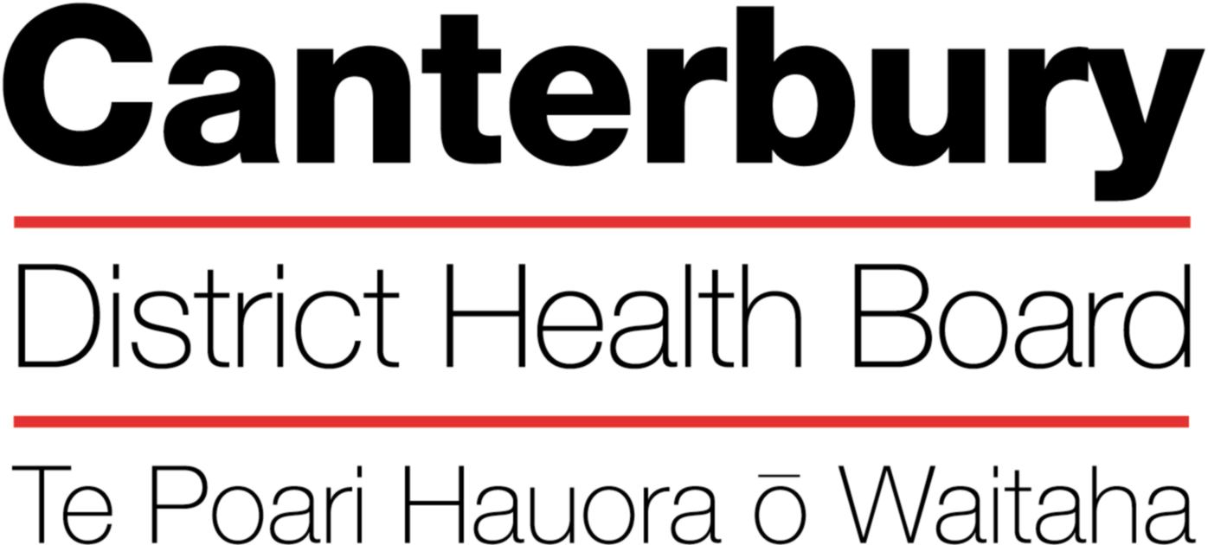

September 2022

This Position Description is a guide and will vary from time to time and
between services and/or units to meet changing service needs

The Canterbury District Health Board is committed to the principles of the Treaty of Waitangi and the overarching objectives of the New Zealand health and disability strategies.

Organisational Vision

The CDHB’s vision is to improve the health and wellbeing of the people living in Canterbury.

Organisational Values

Care & respect for others

Integrity in all we do

Responsibility for outcomes
POSITION TITLE: |  |  | Administrator, Fracture Liaison Service  OPH&R
REPORTS TO (Title): |  |  | Service Manager
REPORTS ON A DAILY BASIS TO: |  |  | Clinical Nurse Specialist
PRINCIPAL OBJECTIVES

The Administrator will provide administrative and secretarial support to the FLS team members.
FUNCTIONAL RELATIONSHIPS:

INTERNALLY:
1 | FLS Team clinical staff
2 | Other CDHB employees
EXTERNALLY:
1 |  | Clients/family/whanau/caregivers
2 |  | Service providers
3 |  | Community and Service agencies
4 |  | General Practitioners and Primary Health Organisations
5 |  | Informal providers.

KEY PERFORMANCE OBJECTIVES:

Task | Provide administrative and secretarial support to all staff within the FLS as required
Expected Result | - General administrative and secretarial tasks, including typing reports and letters, entering information onto the patient management system, the fracture registry, filing, answering telephones, photocopying, e-mailing and other administrative and secretarial tasks will be carried out in an efficient manner.  - Demonstrated ability to prioritise work and communicate effectively with team members.
Task | Support the Clinical Team members to meet the KPIs for the FLS
Expected Result | - Record information accurately and maintain the integrity of the database.  - Prepare reports as requested.  - Demonstrate communication skills in obtaining and giving accurate information to relevant agencies and individuals.
Task | Ensure data entry is achieved in an accurate and timely manner and data bases are maintained.
Expected Result | - Data entry for client contacts and other FLS processes.  - Compilation and collating of statistical data  - Integrity of data will be protected by following defined process.  - The Clinical Manager will be informed if there are issues that need to be addressed.
Task | Customer Service
Expected Result | - Promote the FLS in a positive and accurate manner to the public, consumers and other staff members.  - Handle enquiries effectively and efficiently by being able to identify the needs of both internal and external customers and provide the appropriate assistance.  - Maintain confidentiality and sharing information in accordance with the Privacy Act by demonstrating knowledge and application of legislation governing obtaining, releasing, and storing client information.  - A high standard of courtesy and dignity is always shown.  - Relay messages in a timely and effective manner with consideration given to priority.
Task | Participate in development of the team.
Expected Result | - Actively participate in team discussions and service development.  - Actively seek ongoing training and personal development.  - Share knowledge with other team members
Task | Participate in the Performance Appraisal process
Expected Result | - Undertaken on an annual basis and work towards achieving goals set during the appraisal process.  - Participate in ongoing training and development as required.

HEALTH & SAFETY:

- Observe all Canterbury DHB safe work procedures and instructions
- Ensure your own safety and that of others
- Report any hazards or potential hazard immediately
- Use all protective equipment and wear protective clothing provided
- Make unsafe work situations safe or, if they cannot, inform your supervisor or manager
- Co-operate with the monitoring of workplace hazards and employee’s health
- Ensure that all accidents or incidents are promptly reported to your manager
- Report early any pain or discomfort
- Take an active role in the Canterbury DHB’s rehabilitation plan, to ensure an early and durable return to work
- Seek advice from your manager if you are unsure of any work practice

QUALITY:
Every staff member within CDHB is responsible for ensuring a quality service is provided in their area of expertise. All staff need to be involved in quality activities and should identify areas of improvement. All staff are required to be familiar with and apply the appropriate organisational and divisional policies and procedures.

QUALIFICATIONS & EXPERIENCE:
Essential
- Experience as an administrator in a complex organisation
- Accurate, competent computer skills, including competence in Word and Excel
- Client focussed approach
- Ability to type to a standard of 60-70 words per minute
- Proven ability to work in a team and individually
- Ability to effectively organise, update and disseminate information
- Ability to express yourself clearly and concisely, both verbal and written
- Able to prioritise work to achieve objectives
- Demonstrate a commitment to developing an understanding of the Treaty of Waitangi, Maori and other cultural issues as related to the FLS.
- Demonstrate a professional attitude including self and team care

Desirable
- Experience in the field of health.
- Experience with the patient management system

PERSONAL ATTRIBUTES:

Essential

Key Behaviours:
- Ability to “work together” in a truthful and helpful manner.
- Ability to “work smarter” by being innovative and proactive.
- Accept responsibility for actions.
- Ability to work under pressure

The intent of this position description is to provide a representative summary of the major duties and responsibilities performed by staff in this job classification. Staff members may be requested to perform job related tasks other than those specified.

