POSITION DESCRIPTION | 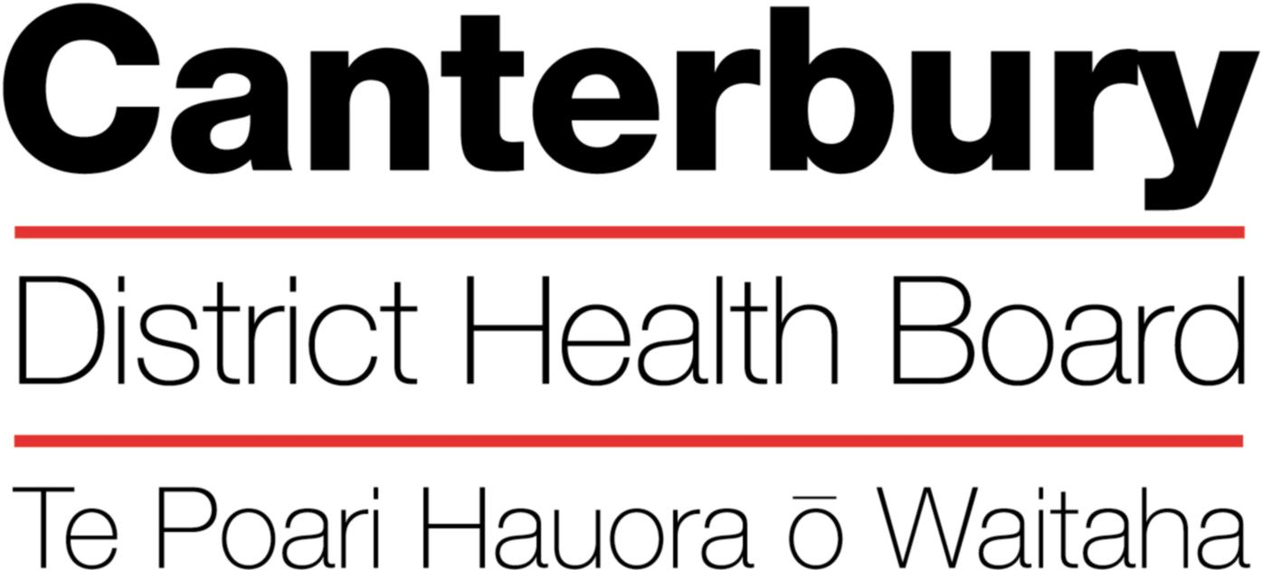

June 2022
This Position Description is a guide and will vary from time to time and
between services and/or units to meet changing service needs

The Canterbury District Health Board is committed to the principles of the Treaty of Waitangi and the overarching objectives of the New Zealand health and disability strategies.

Organisational Vision
The CDHB’s vision is to improve the health and well being of the people living in Canterbury.

Organisational Values
- Care & respect for others
- Integrity in all we do
- Responsibility for outcomes
NAME:
POSITION TITLE: |  |  | Consultant Physician/Geriatrician
REPORTS TO (TITLE): |  |  | Clinical Directors, OPH (Inpatient or Community Clinical Director)
PRINCIPAL OBJECTIVES

To contribute to the provision of high quality Specialist Services for the Health of Older People in Canterbury in both hospital and community settings in accordance with the CDHB’s Health of Older People Strategy.
FUNCTIONAL RELATIONSHIPS:
(Who are the customer/consumers/patients)
INTERNALLY:
1 | Chief of Service, OPH&R
2 | Clinical Directors, Older Persons Health (Inpatient, Community)
3 | Resident Medical Officers
4 | Consultant colleagues
5 | OPHSS Management Team
6 | Older Persons Mental Health
7 | Multi-disciplinary Health Professionals
8 | Clerical support
9 | Quality and patient safety team
EXTERNALLY:
1 |  | Patient, their families and their caregivers
2 |  | General Practitioners
3 |  | Other referring and support agencies and NGO’s
4 |  | University and Christchurch School of Medicine

GENERIC PERFORMANCE OBJECTIVES:

Task | To provide specialist Geriatrician advice for the planning and delivery of health/disability services for older people at a population level. This may be within the CDHB region or nationally if required.
Expected | - Be available for giving advice on changes in service planning and delivery, which may involve regular meetings as required.  - Respond proactively to changes in population demography or the health needs of older people by making suggestions for change in health/disability service delivery.
Task | To provide a high standard of clinical care to patients accessing Older Persons Health Specialist Service
Expected Result | - Maintain a high standard of clinical practice in accordance with statutory and regulatory requirements, standards documented by relevant professional bodies, the Health and Disability Commissioner and policies of the CDHB except to the extent that they may be inconsistent with any other provisions of this agreement.  - Practise and foster development of the patient-focused, interdisciplinary, evidence-based approach to patient care  - Work within their own competencies and Scope of Practice  - Conduct clinical activities in accordance with their schedule using the allocated time and resources efficiently and effectively for patient care  - Communicate with other healthcare professionals in a timely and effective manner to ensure a high standard and continuity of clinical care  - Delegate clinical responsibility, when necessary, in an appropriate manner.
Task | To contribute to maintenance and improvement of Service Quality and Patient Safety
Expected Result | - Ensure timely management of issues arising that may threaten patient safety or satisfaction, involving other parties including the Clinical Director as appropriate.  - Comply with the CDHB’s reportable events and complaints policies, and other relevant policies and procedures.  - Maintain knowledge of relevant legislation, policies and protocols.  - Be closely involved in OPHSS’s quality activities including regular attendance and contribution to clinical audit, journal club, Grand Rounds, peer review meetings and other clinical meetings  - Be responsible for his/her own continuing medical education programme and maintenance and development of clinical skills and knowledge to the standard required by the relevant regulatory bodies.  - Participate in the development of clinical practice policies and guidelines.  - Encourage evidence-based practice.
Task | To contribute to the running and development of the Older Persons Health Specialist Service
Expected Result | - Ensure regular attendance at fortnightly Consultants meetings.  - Contribute to administrative aspects of the Service such as rosters, RMO management and sub-specialty administration  - Be involved, as agreed with the Clinical Director, in Service development activities and sub-specialty development  - Demonstrate awareness of the need to use health service resources wisely

Task | To comply with responsibilities under the Health and Safety in Employment Act 1992
Expected Result | - Maintain knowledge of and promote CDHB health and safety systems and policies to staff  - Report as required to the General Manager, Older Persons Health and Rehabilitation, on health and safety issues and to support the General Manager and Health and Safety staff in carrying out their responsibilities.  - Attend relevant health and safety meetings  - Remain alert to hazards he/she may encounter at work as described in information received from Health and Safety staff.  - Report all accidents and injuries and ensure relevant documentation is completed accurately and forwarded to appropriate authorities as described in the DHBs Health and Safety Policy and Procedures manual.

Specific Tasks – the extent of each to be individually agreed with the Clinical Director, OPH

Task | To provide specialist Geriatrician assessment of frail older patients admitted to OPH wards and to take responsibility for their clinical care
Expected Result | - Assume clinical responsibility for the care of inpatients on a general or specialist OPH ward for a specified number of months per year.  - Carry out consultant-led Ward Rounds at least twice weekly  - Attend interdisciplinary ward board round at least once weekly  - Provide clinical leadership and specialist medical input into IDT clinical assessment, treatment and management planning of individual patients. This includes weekly IDT meetings.  - Participate in and supervise liaison meetings as required.  - Make ad hoc visits to the ward as determined by clinical issues  - Ensure regular communication with ward staff, particularly RMOs, to maintain a high standard of clinical care.  - Provide a high standard of documentation in clinical records  - Supervise and provide prompt discharge communication with GPs and other appropriate agencies.  - Supervise the clinical activities of RMOs attached to the ward  - Provide leadership in partnership with others, particularly the ward Charge Nurse Managers, in the organisation and running of the ward.
Task | To provide specialist physician assessment of frail older patients admitted to the DHB’s general surgical wards
Expected result
- Assist in the management of frail older surgical patients
- Early identification and review of patients requiring inpatient rehabilitation
- Carry out consultant-led Ward Rounds on each ward at least twice weekly
- Make ad hoc visits to the wards as determined by clinical issues
- Provide specialist input into discharge planning and advice on options for community support
- Contribute to IDT meetings and support the Allied Health team
- Participate in and supervise liaison meetings as required
- Provide clinical supervision of the Surgical Medicine Registrar

Task | To provide specialist geriatrician assessment and management advice for older people in a variety of outpatient settings including Medical Outpatients
Expected Result | - Carry out regular Medical Outpatient clinics to see first referrals from a variety of referral sources, and follow-up patients including those reviewed after discharge from the ward.  - Use Telehealth for clinical reviews where appropriate and available  - Ensure prompt dictation and signing of correspondence.  - Ensure appropriate follow up of investigations
Task | To provide specialist geriatrician assessment and management advice for older people in a community setting within the Canterbury and West Coast District Health Boards (Community SMO)
Expected Result | - Provide clinical oversight and supervision for the Community Services Teams  - Participate in the triage process of the Adult Community Referral Centre (ACRC)  - Participate in Interdisciplinary Team meetings of the OPH Community Services Teams in Canterbury and the West Coast  - Provide specialist geriatrician and rehabilitation advice for patients managed by Community Services Teams in Canterbury and the West Coast  - Provide leadership in partnership with others, particularly the Clinical Managers, in the organisation and running of the Community Services Teams in Canterbury and the West Coast  - Undertake community consultations, in conjunction with a Community Geriatric Nurse, or other health professionals or alone in patients’ homes and residential facilities in Canterbury and the West Coast  - Ensure high standard of documentation in clinical records  - Supervise and ensure prompt discharge communication with GPs and other appropriate agencies.  - Provide clinical oversight of the Community Rehabilitation, Enablement and Support Team (CREST).  - Liaise pro-actively with teams in the wider Canterbury and West Coast DHBs to facilitate optimal management of older people in their care.  - Provide telemedicine services to assist in the above tasks where appropriate.  - Provide on-site input for the above services in Canterbury and the West Coast where appropriate.
Task | To provide specialist geriatrician assessment and management advice for older people in a community setting (Ward SMO)
Expected Result | - Regularly attend the Community Service Team (CST) meetings  - Participate in weekly IDT meeting of the Community Stroke Rehab Service (CSRS).  - Provide specialist geriatrician and rehabilitation advice for patients managed by CSRS, Community Service Teams (CST), and Community Rehabilitation Enablement and Support Team (CREST)  - Provide leadership in partnership with others, particularly the Clinical Managers, in the organisation and running of the CSRS team  - Undertake community consultations, usually in conjunction with a Community Geriatric Nurse, in patients’ homes and residential facilities.
Task | To provide specialist geriatrician assessment of frail older patients admitted to the DHB’s acute orthopaedic wards to take joint responsibility with the orthopaedic surgeon for their clinical care
Expected Result | - Assume clinical responsibility for the care of inpatients on the two acute orthopaedic wards at Christchurch Hospital or the Orthopaedic Rehabilitation Unit based at Burwood Hospital for a specified number of months per year.  - Carry out consultant-led Ward Rounds at least twice weekly  - Contribute to weekly IDT meetings  - Participate in and supervise liaison meetings as required  - Ensure high standard of documentation in clinical records  - Provide leadership in partnership with others particularly the ward Clinical Nurse Managers in the organisation and running of the wards  - Make ad hoc visits to the wards as determined by clinical issues  - Ensure regular communication with ward staff, particularly RMOs, to maintain a high standard of clinical care.  - Supervise the clinical activities of RMOs attached to the ward
Task | To provide specialist geriatrician assessment and management advice for older people under the care of other clinical teams within the CDHB at their request
Expected Result | - Liaise pro-actively with teams at Christchurch Hospital and elsewhere in the DHB to facilitate optimal management of older people in their care.  - Ensure timely review and management of verbal and written referrals with review of patients when necessary.
Task | To contribute to teaching and research
Expected Result | - In conjunction with the Christchurch School of Medicine, regularly participate in medical student’s clinical teaching programmes and supervision of learning activities.  - Participate in orientation of RMOs.  - Participate in RMO clinical teaching programmes in conjunction with RACP as appropriate.  - Undertake clinical case teaching as opportunities arise.  - Participate in the education of other disciplines in the organisation where appropriate.  - Contribute to research carried out by the Service and the DHB.

On-Call Responsibilities

Frequency of On-Call
Older Persons Health - 1 in 10 roster

On-Call Responsibilities
- Responsible for the Older Persons Health inpatient wards and supervision of the duty medical staff
- Provide support to OPMH wards for geriatric medicine issues
- Available for phone calls for advice or consideration of patient admission from GPs, Emergency Department, Community teams and CREST

Accountability for On-Call
The consultant will be accountable for:
- Ensuring ready availability either at home, or via mobile phone
- Readiness and availability to see patients in the hospitals within 30 minutes if necessary
- Visiting Burwood Hospital daily, if necessary, when on-call for weekends and public holidays

HEALTH & SAFETY:

- Observe all Canterbury DHB safe work procedures and instructions
- Ensure your own safety and that of others
- Report any hazards or potential hazard immediately
- Use all protective equipment and wear protective clothing provided
- Make unsafe work situations safe or, if you cannot, inform your supervisor or manager
- Co-operate with the monitoring of workplace hazards and employees health
- Ensure that all accidents or incidents are promptly reported to your manager
- Report early any pain or discomfort
- Take an active role in the Canterbury DHB’s rehabilitation plan, to ensure an early and durable return to work
- Seek advice from your manager if you are unsure of any work practice

QUALITY:
Every staff member within CDHB is responsible for ensuring a quality service is provided in their area of expertise. All staff are to be involved in quality activities and should identify areas of improvement. All staff are to be familiar with and apply the appropriate organisational and divisional policies and procedures.

QUALIFICATIONS & EXPERIENCE:
- Current Vocational Registration in General Internal Medicine by the Medical Council of New Zealand
- Postgraduate training in Geriatric Medicine

PERSONAL ATTRIBUTES:

Mandatory

- A commitment to improving the health and well-being of those accessing the service
- Excellent interpersonal skills, ability to communicate well and to work collaboratively within an interdisciplinary team
- A focus on provision of high quality care
- A focus on achieving results
- Proven leadership and team-building qualities
- Ability and confidence to make decisions and to take responsibility for them
- Ability to work under pressure and to manage a variable and sometimes heavy workload
- Ability to provide supervision and teaching to medical and other clinical staff
- An evidence-based approach to their clinical practice
- Ability to use information technology
- A commitment to own career development

Key Behaviours:
- Ability to “work together” in a truthful and helpful manner.
- Ability to “work smarter” by being innovative and proactive.
- Accepts responsibility for actions.
- Ability to provide inspirational and motivational leadership

The intent of this position description is to provide a representative summary of the major duties and responsibilities performed by staff in this job classification. Staff members may be requested to perform job related tasks other than those specified.

