POSITION DESCRIPTION | 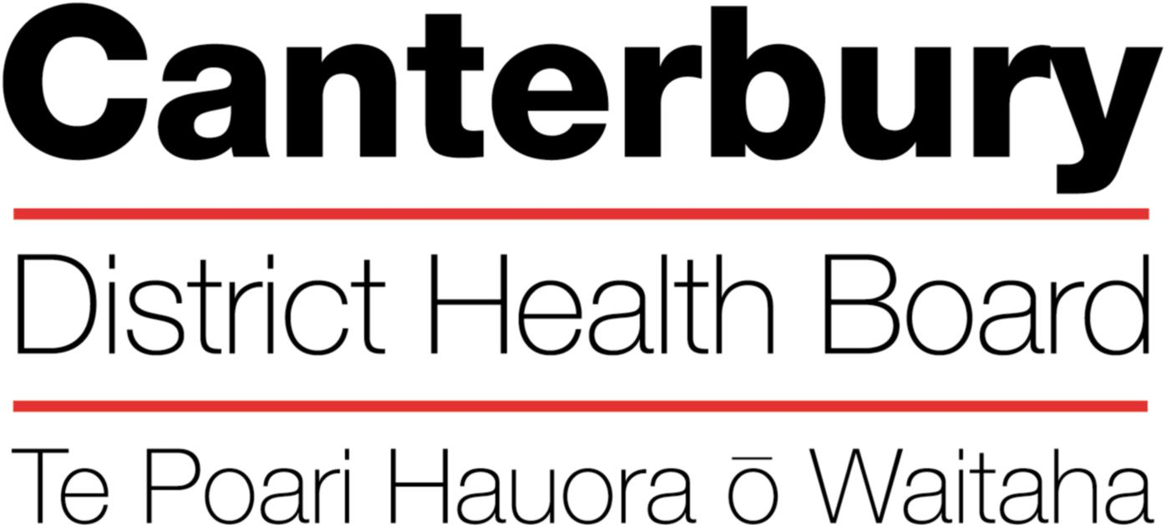

September 2016
This Position Description is a guide and will vary from time to time and
between services and/or units to meet changing service needs

The Canterbury District Health Board is committed to the principles of the Treaty of Waitangi and the overarching objectives of the New Zealand health and disability strategies.

Organisational Vision
The CDHB’s vision is to improve the health and well being of the people living in Canterbury.

Organisational Values
- Care & respect for others
- Integrity in all we do
- Responsibility for outcomes
POSITION TITLE: | Ophthalmology Clinical Fellow (Medical Officer)
REPORTS TO (Title): | Clinical Director, Ophthalmology
PRINCIPAL OBJECTIVES
This role is designed to provide the Fellow with intensive clinical experience in an Ophthalmology sub-specialty, the specific learning objectives being individually determined by the Fellow and Supervisor

This is not exclusive of all other surgery and the Fellow is required to participate in the general ophthalmology service as rostered.
- To be responsible for the assessment and management of patients with ophthalmic conditions under the supervision of the Consultant Surgeon
- To participate in the acute service and the management of patients requiring acute assessment under the supervision of the Acute Surgeon
FUNCTIONAL RELATIONSHIPS:

INTERNALLY:
As required with the Clinical Director, Service Manager, Medical and Nursing staff, Allied Health Professionals and clerical support staff
EXTERNALLY:
As required with Clinicians from Referring Agencies, Christchurch School of Medicine Staff, Community Services

KEY PERFORMANCE OBJECTIVES:
Primarily the role is located at Christchurch Hospital but service needs may dictate the Fellow work at another CDHB site on occasion
Task | To undertake Outpatient clinics for the consultation and clinical management of New and Follow-up Patients, in conjunction with or as directed by the lead Consultant
Expected Results | - Initiates appropriate patient diagnostic investigations based of priority of access  - Patients are provided with all relevant information and are fully informed about their treatment options and anticipated timeframes  - Patients for surgery are prioritised using the appropriate score tool  - Completion of clinical administration is comprehensive and timely.  - Follow-up instructions and additional procedures performed in clinic are recorded on the clinic sheet  - Elective surgery booking forms are completed and submitted to the waitlist coordinator at the end of clinic  - Dictation of clinic letters is completed within 2 (urgent) or 5 days (routine)
Task | To plan and manage the clinical treatment of elective patients
Expected Results | - Performs elective surgical operations and procedures under the supervision of the lead Consultant. This may be direct or indirect supervision as appropriate to assessed level of competence  - Undertakes post-operative assessment ward rounds  - Completion of clinical administration is comprehensive and timely.  - Operation record is completed at the time of surgery  - Discharge letters within 7 days.
Task | To support the assessment and management of patients with acute eye conditions
- To oversee the Registrar assessments in the Acute Eye Clinic as rostered
- To participate in the SMO after hours acute roster as required to assist with leave management
Task | To participate in the clinical audit programme
Expected Result | - Collects audit information for presentation at audit meetings  - Reports sentinel events
Task | To participate in the wider activities of the service
Expected Result | - Assists with the supervision and teaching of other RMOs and trainee interns  - Attends departmental meetings  - Participates in research

HEALTH & SAFETY:

Implement or lead and implement emergency procedures and maintain a safe and secure work environment by following relevant Canterbury DHB and Divisional policies, protocols and standards. This includes but is not limited to:
- Practice safe work habits and ensure the health and safety of yourself and others
- Make unsafe work situations safe or, inform a supervisor or manager
- Is knowledgeable about hazards in the work area ant the procedures in place to identify and control hazards
- Use Personal Protective Equipment correctly and when required
- Report hazards, incidents, accidents, and near misses promptly and accurately
- Seek advice from manager is unsure of work practices
- Complete mandatory training as required
- Is knowledgeable of emergency procedures and evacuation plans
- Assists in maintenance of equipment as required, and reports faulty equipment promptly
- Actively practice clinical standard precautions

QUALITY:
Every staff member within CDHB is responsible for ensuring a quality service is provided in their area of expertise. All staff are to be involved in quality activities and should identify areas of improvement. All staff are to be familiar with and apply the appropriate organisational and divisional policies and procedures.

QUALIFICATIONS & EXPERIENCE:
Essential
Must have passed RACE exams
Eligible for registration with New Zealand Medical Council

Desirable
Experience in a public health system comparable to New Zealand
FRANZCO or equivalent

PERSONAL ATTRIBUTES:

Mandatory

Key Behaviours:
- Ability to “work together” in a truthful and helpful manner.
- Ability to “work smarter” by being innovative and proactive.
- Accepts responsibility for actions.
Desirable

The intent of this position description is to provide a representative summary of the major duties and responsibilities performed by staff in this job classification. Staff members may be requested to perform job related tasks other than those specified.

