POSITION DESCRIPTION | 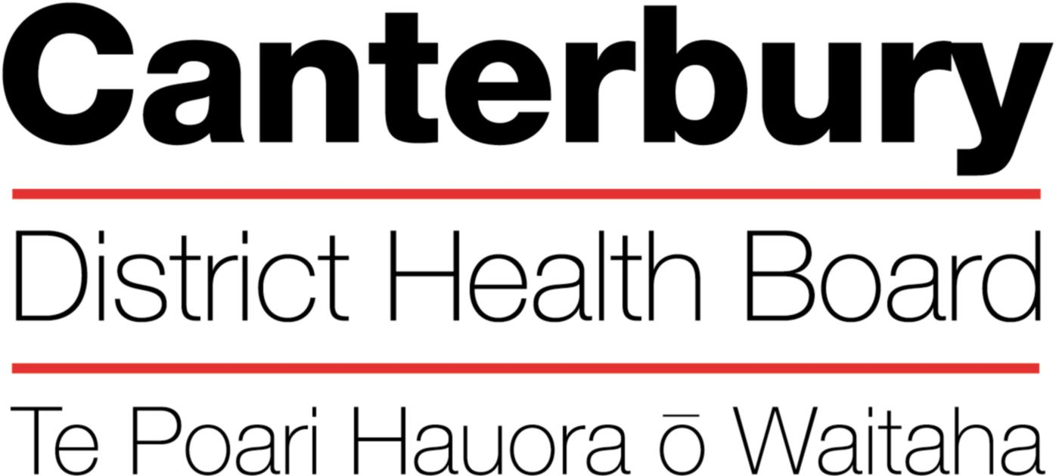

August 2017
This Position Description is a guide and will vary from time to time and
between services and/or units to meet changing service needs

The Canterbury District Health Board is committed to the principles of the Treaty of Waitangi and the overarching objectives of the New Zealand health and disability strategies.

Organisational Vision
The CDHB’s vision is to improve the health and well being of the people living in Canterbury.

Organisational Values
- Care & respect for others
- Integrity in all we do
- Responsibility for outcomes
POSITION TITLE: |  | Registered or Clinical PSYCHOLOGIST
REPORTS TO (Title): |  | Clinical Manager
REPORTS ON A DAILY BASIS TO: |  | Clinical Manager
PRINCIPAL OBJECTIVES

To provide a high quality and comprehensive clinical psychology service for young people with moderate to severe mental health problems, and their families.

FUNCTIONAL RELATIONSHIPS:
(Who are the customer/consumers/patients)

INTERNALLY:
1 | Consumers, families and carers
2 | Multidisciplinary team
3 | Clinical Lead/Clinical Manager
4 | Professional Practice Leader
5 | Consumer and Family Advisors
6 | Supervisor

EXTERNALLY:
1 | Consumer and Family Representatives
2 | Relevant external agencies in Mental Health and Social Services

KEY PERFORMANCE OBJECTIVES:

Task | To provide comprehensive mental health assessments, utilising clinical interviewing, diagnostic, behavioural and appropriate psychometric assessment based on current literature (and availability) as required.
Expected Result | - A comprehensive assessment is completed and discussed with the Team.  - Clear written assessment report  - Appropriate and timely written reports (in accordance with Service SPF requirements).  - Reports will include a clear psychological formulation, diagnosis and appropriate treatment recommendations/plan.  - Assessment is completed following principles of cultural safety.  - Significant others/family involved as appropriate
Task | To deliver a variety of empirically based interventions to individuals, couples, families or groups with complex needs as appropriate to the setting and presenting problems via a model of case-management
Expected Result | - Clients have documented Management/Treatment plans  - Clients understand their Management Plan.  - Uses appropriate, accepted models of intervention/therapy, based on current literature; and as per the Team’s Philosophy & Service Provision Framework.  - Able to devise behavioural or psychological programmes for other Mental Health disciplines, or client’s significant others to implement.  - Consultation with other health professionals in the Team regarding clients’ needs/management.  - Treatment/intervention is culturally safe and includes consultation with Maori Health Workers, as appropriate.  - Involvement of significant others/family, as appropriate.  - Knowledge and ability to work effectively and collaboratively as a case manager in a system of care approach.  - Provision of Case Management involving co-ordination of ongoing assessment, treatment, review and discharge planning to assigned/negotiated case load. Assigned caseload will depend on the level of other professional responsibilities e.g., supervision, teaching, research, professional meetings, delegated responsibilities.
Task | Will present material to Service or other groups, in order to inform practice and convey a psychological perspective on clinical issues.  Will participate in peer group education review and participate in appropriate training and re-training workshops, conferences, and seminars incorporating study leave.
Expected Result | - Provision of psychological knowledge and expertise for other professionals within the Team and across teams as required.  - May provide community groups and relevant organisations with appropriate psychological knowledge.  - Exchange of ideas and sharing of skills through consultation with colleagues.  - Attend agreed study events and provide evidence of attendance.
Task | Close consultation with medical and other health professionals within the team/Mental Health Service and co-operation and co-ordination with other referring agencies to ensure the delivery of the best service and care possible
Expected Result | - Providing contribution to the treatment plans at assessment presentations and patient review meetings.  - Provision of psychometric assessment and psychological treatment within the Team or across teams, as required.  - Provision of psychological knowledge and expertise for other professionals within the Team and across teams as required.  - Consultation with Regional/National groups (e.g., professional bodies, Ministry of Health), as required.
Task | Participate in or initiate research programmes.
Expected Result | - Contribute to the design, data collection, analysis, and write up of research projects as appropriate.  - Presentation of findings to Team/Unit and other appropriate forums.  - Contribute to the publication of research.
Task | Set personal and professional goals and objectives. Regularly review them with appropriate management and/or professional advisor.
Expected Result | - Work roles are reviewed regularly. Efficiency and job satisfaction are maintained.
Task | Practice is professional and ethical/medico-legal requirements are met.
Expected Result | - Demonstrate a working knowledge of legal requirements of the Mental Health Act, Property and Welfare Acts and Privacy of Information code.  - Complete all documentation concisely, accurately and objectively.  - Demonstrate a working knowledge of all legal and ethical requirements pertaining to informed consent, seclusion, restraint and any other procedure likely to affect a patient’s right and balance with public safety.  - To act as a Duly Authorised Officer if required by the Director of Area Mental Health having first been given appropriate training and authorisations.  - Practice is professionally competent in accordance with the Standards of Practice/Code of Ethics, as set down by the Psychologist Board and Psychologists’ Act.
Task | Participate in the formulation and initiation of Service or Division CDHB policy as required.
Expected Result | - Contribute to Service philosophy and objectives from a psychological view  - Contribute to local and national issues based on experience and area of speciality
Task | To perform delegated responsibilities additional to those in the job description, by negotiation.
Expected Result | Initiate negotiations on change in job description as appropriate
Task | To ensure all activities and activity levels are both consistent with and meet the goals as stated within the Team business plan and individual job plan.
Expected Result | - To develop and review an individual job plan including day to day work on a regular basis with the Clinical Manager  - To contribute to the business planning within the Team as required  - To meet all contact activity levels from the business plan as required  - To be fully conversant with the Business Plan and targets for year as required  - To maintain negotiated activity levels throughout the year.  - Ensure that performance audit and quality assurance programmes are implemented, monitored and met, as required.

QUALIFICATIONS & EXPERIENCE:
Essential
- A recognised Clinical Psychology qualification (Masters or Bachelors Honours Degree in Psychology and Diploma in Clinical Psychology or overseas equivalent).
- Registration with the New Zealand Psychologists’ Board or eligible for registration.
- Specialist training in Child and Adolescent mental health – Post Grad Diploma in Child and Family Psychology or Post Grad Diploma in Clinical Psychology.
- Clinical experience in working in a child and/or adolescent mental health service.
- Good assessment skills and a sound knowledge of available treatment options.

PERSONAL ATTRIBUTES:

Mandatory

Key Behaviours:
- Ability to “work together” in a truthful and helpful manner.
- Ability to “work smarter” by being innovative and proactive.
- Accepts responsibility for actions.
- Ability to provide inspirational and motivational leadership Demonstrated commitment to ongoing professional development.

- High degree of initiative and motivation.
- Good organisational and interpersonal skills and the ability to communicate effectively both orally and in writing.
- The ability to accept and carry professional accountability and responsibility.

HEALTH & SAFETY:

- Observe all Canterbury DHB safe work procedures and instructions
- Ensure your own safety and that of others
- Report any hazards or potential hazard immediately
- Use all protective equipment and wear protective clothing provided
- Make unsafe work situations safe or, if they cannot, inform your supervisor or manager
- Co-operate with the monitoring of workplace hazards and employees health
- Ensure that all accidents or incidents are promptly reported to your manager
- Report early any pain or discomfort
- Take an active role in the Canterbury DHB’s rehabilitation plan, to ensure an early and durable return to work
- Seek advice from your manager if you are unsure of any work practice

QUALITY:
Every staff member within CDHB is responsible for ensuring a quality service is provided in there area of expertise. All staff are to be involved in quality activities and should identify areas of improvement. All staff are to be familiar with and apply the appropriate organisational and divisional policies and procedures.

The intent of this position description is to provide a representative summary of the major duties and responsibilities performed by staff in this job classification. Staff Members may be requested to perform job related tasks other than those specified.

