TEAM | Physiotherapy
ROLE TITLE | Advanced Allied Health Professional - Critical Care
REPORTS TO  SALARY BANDING | Allied Health Leader – Clinical Manager, Physiotherapy  Steps 9 - 13 on the degree-based Allied, Public Health & Technical Pay Scale 5.2

OUR CULTURE  OUR TEAM ACCOUNTABILITY | At Waitaha Canterbury and Te Tai o Poutini West Coast, we are committed to honouring Te Tiriti o Waitangi and its principles by ensuring our partnership with Māori are at the forefront of all our conversations. We are also committed to putting people at the heart of all we do, so that we are all supported to deliver world class healthcare to our communities. This means we all behave with honesty, integrity and courage; doing the right thing by each other and our communities. We demonstrate care and concern for our own and others wellbeing. We believe that diversity and inclusion is critical to ensure we deliver the best care for our diverse communities. Therefore, we always respect and value everyone’s differences. When making decisions we consider and seek a diverse range of viewpoints especially those from minority groups.  As a member of the Physiotherapy Team, you will actively support and enable Waitaha Canterbury and Te Tai o Poutini West Coasts’ Strategic Direction and the aligned Allied Health Strategic Plan, as a result this role has shared accountability for:  - Support and participation in clinical governance and quality improvement activities to increase collaboration, reduce and eliminate waste.  - Commitment and participation in system and service improvement and transformation to enhance equity and outcomes of the tāngata and their whānau.  - Growth and development of a more capable and diverse Kaiāwhina (Allied Health) workforce aligned with current Waitaha Canterbury and Te Tai o Poutini West Coasts’ healthcare delivery models.  - Active partnership, participation and empowerment of our tāngata whaiora and their whānau through effective use of prevention and early intervention and enablement strategies.  - Implementation and utilisation of data and technology to plan, evaluate and modify the way we deliver efficient care that is timely and responsive and empowering our tāngata whaiora to take greater responsibility for their wellbeing.  - Encouragement, facilitation and utilisation of on-going feedback, data and systematic exploration and implementation of universal and targeted health care support that is underpinned by evidence and best practice, as well as cultural input and co-design process.  - Effective engagement and support of growth, success and development activity, including creating opportunities for other Allied Health professional groups to build capacity and capability beyond individual professions and clinical skill.  - Support and optimisation of professional development and clinical education through inter-professional learning, skills sharing, delegation, positive practice and a growth culture and behaviours to enhance inter-professional and person-centred models of care.  - Support, encouragement, promotion and celebration of Allied Health research, innovation and improvement across all professional disciplines within the Canterbury and the West Coast systems.  - Proactive performance management of staff including behaviours, attitudes and wider contribution to team goals.

MY ROLE RESPONSIBILITY | As per South Island Allied Health Career Framework, Advanced/Generalist with Special Interest provides safe and clinically effective patient/client assessment and intervention with demonstration of advanced knowledge and skills in an area of special interest and/or more broadly across a range of services to manage complex presentations. This role will/may also have responsibility for providing clinical leadership within the team or service which assists in developing the clinical capability of others.  The Advanced Allied Health Professional is expected to spend time primarily focussed on the clinical practice pillar. There will be less time spent on the other pillars. How this is divided across the pillars will be dependent on the demands and requirements of the particular role. It will be necessary for this role to have dedicated time to meet the expectations across the pillars.  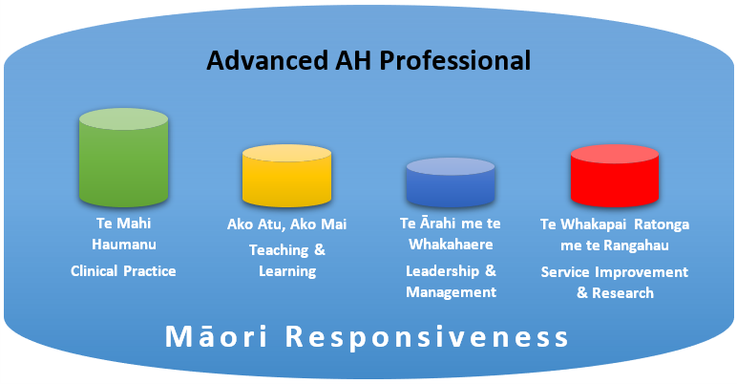  Specifically, the role is responsible for:  - Management of clinical case load primarily focusing on the provision of basic and specialised clinical advice or information in relation to the care or education of tāngata whaiora directly or through other staff members, performing assessments of clinical care needs (including diagnosing), development, consultation and implementation of clinical care/interventions or therapy programmes.  - Effectively planning and managing your own clinical and non-clinical time while working with other internal and external tāngata (stakeholders) and supporting formal and informal programmes of education or training.  - Be involved in service and policy development by commenting, proposing changes, with a potential requirement of creating and/or actively implementing evidence based clinical policy within the section, department, service, directorate or the whole organisation, including support to staff to participate in and contribute to quality improvement activities.  - Day to day use of general and specialty equipment, stock control, as well as training other staff and tāngata whaiora on safe equipment use practices and maintenance.  - Providing clinical, professional and/or cultural leadership and/or supervision of staff and students across teams, departments or service area.  - Acting as an advanced practitioner in the field delivering professional leadership and supervision of clinical activity and practice, through provision of advanced clinical advice, consultation and support to clinical practitioners, while working within professional or occupational policies and being accountable for own professional actions.  - Supporting and enabling education of staff through effective learning needs analysis, skills sharing and delegation framework implementation, both within the Allied Health profession and inter-disciplinary teams, including clinical or non-clinical skills development in one on one or group setting, including support of recruitment and workforce development components, and orientation, mentoring & coaching of new staff  - Carrying out clinical audits, participating and supporting research and development, clinical trials and equipment testing.  - Contributing to identification of targets and goals for a department, division, service area/s or organisation and supporting corresponding informatics processes, such as data gathering and reporting (Care Capacity Demand Management (CCDM), KPIs, incident management).  - Following national, regional or organisational policies, legislation and initiatives, and take appropriate actions as well as facilitate your colleagues understanding and integration to these.  - Supporting projects and project related work, participation in steering groups and consultation processes.  - Contributing to the development, review and promotion of care pathways for people requiring restorative care/reablement/rehabilitation through a range of interventions.  - Demonstrating an understanding of the fiscal implications of clinical decisions and acting accordingly.  - Performing other duties considered to be within the scope of this role as agreed by you and your manager.

MY CAPABILITY | To be effective and succeed in this role it is expected the person will have proven capabilities against the Specialist Leadership focus:  The core focus of their role is to advise and support other leaders in developing and delivering strategy. They have responsibility for determining how to solve organisational or clinical challenges and are often asked to advise on the best course of action.  - Cultural Responsiveness – works collectively with Māori to uphold the principles of Te Tiriti o Waitangi and supports Canterbury and the West Coast DHBs’s vision of ensuring equitable outcomes for Maori.  - Leading with Influence - Lead and communicate in a clear, inclusive and inspiring way; to influence others to embrace change and take action.  - Leads Strategically - Think, plan, and act strategically; engage others and partner with Māori in the vision and values, and position teams/the organisation/the sectors to meet future needs of the people we care for.  - Enhancing Organisational Performance - Drive innovation and continuous improvement; to sustainably strengthen organisational performance, ensure equitable outcomes for Māori and improve outcomes for our patients.  - Engaging others - Connect with people; to build trust and become a leader that people want to work with and for.  - Resilient and Adaptive - Show composure, resolve, and a sense of perspective when the going gets tough. Helps others maintain optimism and focus.  - Honest and Courageous - Delivers clear messages and makes decisions in a timely manner; to advance the longer-term best interests of the people we care for.  Clinical/Technical skills:  - Computer and typing skills, including knowledge and experience using Microsoft Office Suite and tools including Word, Excel and Teams.  - Experience in using Patient Management systems and Telehealth.  - Other specialised training as applicable to the specialty of the role.  - Mandatory training as required for the role.  Essential:  - Minimum a Bachelor degree in the relevant profession.  - NZ Registration with the relevant professional body.  - A current Annual Practicing Certificate with the relevant professional body and scope of practice.  - Minimum 5 years of clinical practice with minimum of 3 years of clinical work experience in the relevant field of specialty and environment.  - Experience with clinical teaching/supervision, training and development of staff.  - Experience making judgements in complex situations where there is incomplete information or solutions are not obvious.  - Experience in people leadership and/or management.  - Experience in quality /service improvement activities.  - Knowledge of NZ Health & Disability sector standards and the Privacy Act within a health context.  Desirable:  - Advanced experience, education and/or qualification in the area of specialty that is applicable to the role.  - Relevant postgraduate qualification or working towards one.

MY RELATIONSHIPS TO NURTURE | Internal  - Service, Clinical and Case Managers and Leaders  - Executive Director of Allied Health, Scientific and Technical (EDAHST), DAHs and Associate DAHSTs  - New entry, Professional, Advanced, and Consultant Professionals  - Allied Health Educators, Coordinators and Professional Leaders  - Nursing and Medical professionals and leaders  - Union Delegates | External  - Tāngata whaiora and their whānau  - Other professional colleagues across the Canterbury region and nationally (and internationally as appropriate)  - Relevant training institutions  - Support Groups  - Professional Associations and Regulatory Authorities  - Consumer Groups, family-whānau groups  - Other stakeholders e.g. NGOs, government departments and agencies, e.g. aged care  - Mana whenua ki Waitaha  - Local Iwi  - Union Partners

OUR WELLBEING, HEALTH AND SAFETY | At Waitaha Canterbury and Te Tai o Poutini West Coasts, we're committed to promoting a culture where our people's wellbeing, health and safety is at the core of everything we do. We're committed to a healthy and safe working environment to enable everyone to return home safe and well every day. We're driving for a positive, inclusive, engaging culture where our people feel safe and engaged in their work.  We know that it's really important to look after yourself, in order to provide the best possible care to our community. We are all responsible for the health and safety of ourselves and each other. We need to work together to ensure wellbeing, health and safety risks do not put our people at risk of harm.

