POSITION DESCRIPTION | 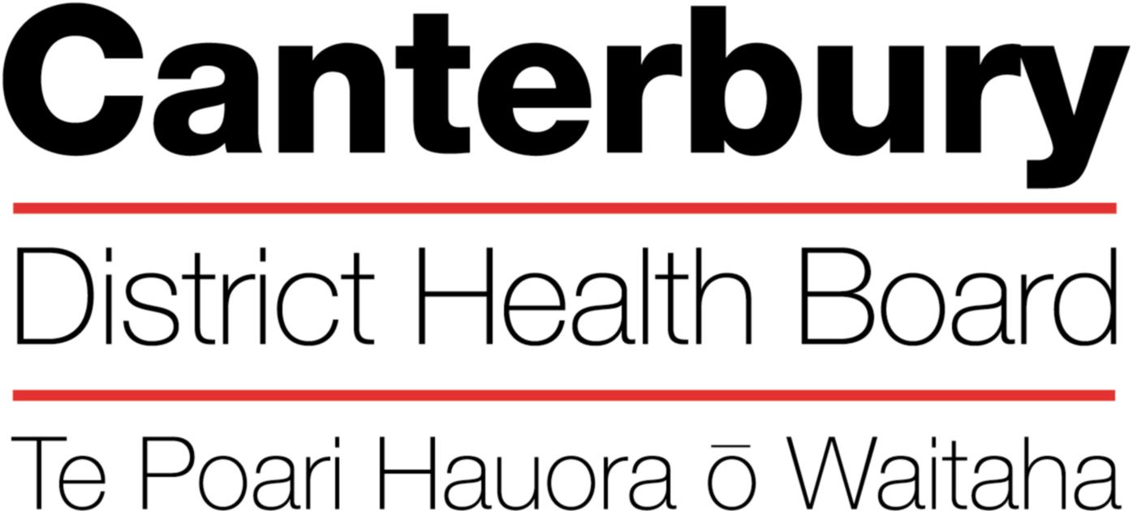

<date>
This Position Description is a guide and will vary from time to time and
between services and/or units to meet changing service needs

The Canterbury District Health Board is committed to the principles of the Treaty of Waitangi and the overarching objectives of the New Zealand health and disability strategies.

Organisational Vision
The CDHB’s vision is to improve the health and well being of the people living in Canterbury.

Organisational Values
- Care & respect for others
- Integrity in all we do
- Responsibility for outcomes
POSITION TITLE: |  |  | Registered Nurse Nephrology
REPORTS TO (Title): |  |  | Charge Nurse Manager, Dialysis Services
REPORTS ON A DAILY BASIS TO: |  |  | CNM Dialysis Services,Nephrology SMOs/CNS’
SCOPE OF PRACTICE
The Registered Nurse will utilise nursing knowledge and complex nursing judgement to assess health needs and provide care, and to advise and support people to manage their health. The RN practises independently and in collaboration with other health professionals and performs general nursing functions. The RN also provides comprehensive nursing assessments to develop, implement, and evaluate an integrated plan of health care, and provide nursing interventions that require substantial scientific, technology and professional knowledge and skills and decision making. This occurs in a range of settings in partnership with individuals, families, whanau and communities. The RN may practice in a variety of clinical contexts depending on the nurse’s educational preparation and practice experience. The RN also uses this expertise to manage, teach evaluate and research nursing practice.
FUNCTIONAL RELATIONSHIPS:

INTERNALLY:
1 | Charge Nurse Manager, Dialysis Services
2 | Nephrology Department SMOs and RMOs
3 | Clinical Nurse Specialist Nephrology
4 | Clinical Nurse Specialist Anaemia/Research - Nephrology
5 | Nephrology Nursing Staff
6 | Allied Health staff
7 | Nurse Educator Nephrology
8 | Renal Transplant Coordinators
EXTERNALLY:
1 |  | Patients and their families/whanau
2 |  | Other health care providers

KEY PERFORMANCE OBJECTIVES:

Task | To attend and manage nursing interventions resulting from the daily transplant clinic.
Expected Result | - Liaise with Transplant SMO  - Manage wound dressings and follow up reviews  - PICC care and blood taking  - CVAD cares (tunnel lines left insitu)  - CAPD catheter cares  - Administer medications as prescribed  - Administer IV fluids  - Indwelling urethral catheter insertion(male and female) and trial of void  - Drain care including removal and ongoing follow up  - Community referrals – District nurse for wound care  - Internal referrals – Wound/Diabetes/Vascular  - PICO/NPWT management  - Patient education as required  - Documentation
Task | To manage the renal biopsies and tunnel line removals
Expected Result | - Be the point of contact when a renal biopsy/tunnel line removal is booked.  - Ensure the treatment room in Ward 14 is booked  - Prepare the equipment required  - Assist the SMO performing the biopsy/tunnel line removal  - Monitor the patient  - Hand patient over to ward staff post biopsy  - Documentation  - Post procedure education for the patient
Task | To demonstrate effective interpersonal relationship skills
Expected Result | - Establishes, maintains and concludes therapeutic interpersonal relationships with patient  - Practises nursing in a negotiated partnership with the patient where and when possible  - Communicates effectively with patients and members of the health care team  - Maintains privacy and confidentiality at all times.
Task | To manage the patients presenting for surgery/tunnel line insertions/other procedures in Adult Surgical Admissions (ASA)
Expected Result | - Notified of impending admission to ASA  - Ensure PD Catheter/TL/NTL and dressing pack sent to IR  - Attend ASA to insert IV cannula for pre op patients
Task | To take on some departmental research and anaemia management to provide cover for CNS Anaemia.
Expected Result | - Work alongside CNS Anaemia – Assist in aspects of that role such as patient education and follow-up remote contact  - Assist with research being undertaken within department
Task | Other tasks
Expected Result | - Attend consultant ward rounds Monday/Wednesday/Friday morning as required  - Attend Thursday Nephrology clinics as needed  - Assist with triaging phonecalls  - Cover for Nephrology CNS/Transplant Coordinators leave  - Be responsible for stocking and maintaining the 3 clinic rooms – ensuring dressing supplies, wound care, IV tubing etc available.  - Meet regularly with CNS Nephro and Anaemia  - Be responsible for updating patient information and other relevant documents.
Task | To implement emergency procedures and maintain a safe and secure environment by following relevant Canterbury District Health Board policies, protocols and standards.
Expected Result | This includes but is not limited to:  - Demonstrates competence in emergency procedures, e.g. fire, cardiac and respiratory arrest, airway protection  - Promptly initiates first aid/emergency actions and summons emergency response personnel and provides further emergency assistance  - Completes Fire, IV and CPR training and updates regularly as required by CDHB’s policies and procedures  - Identifies, takes appropriate action and promptly reports clinical, Occupational Safety & Health and security incidents  - Assists in the maintenance of ward equipment and where necessary, promptly reports unsafe or malfunctioning equipment  - Maintains standards for safety, hygiene and medico-legal requirements

HOURS OF WORK: 1.0 FTE
Full time employment equates to 40 hours per week or 1.0 FTE. Monday to Friday

HEALTH & SAFETY:

- Observe all Canterbury DHB safe work procedures and instructions
- Ensure your own safety and that of others
- Report any hazards or potential hazard immediately
- Use all protective equipment and wear protective clothing provided
- Make unsafe work situations safe or, if they cannot, inform your supervisor or manager
- Co-operate with the monitoring of workplace hazards and employees health
- Ensure that all accidents or incidents are promptly reported to your manager
- Report early any pain or discomfort
- Complete mandatory training as required
- Take an active role in the Canterbury DHB’s rehabilitation plan, to ensure an early and durable return to work
- Seek advice from your manager if you are unsure of any work practice

QUALITY:
Every staff member within CDHB is responsible for ensuring a quality service is provided in there area of expertise. All staff are to be involved in quality activities and should identify areas of improvement. All staff are to be familiar with and apply the appropriate organisational and divisional policies and procedures.

QUALIFICATIONS & EXPERIENCE:
Essential
- Be registered with the New Zealand Nursing Council as a Registered Nurse
- Hold a current Nursing Council of New Zealand annual practising certificate.

- Cannulation competency
- Venepuncture competency
- CVAD competency
- Basic wound care including PICO/NPWT
- Male catheterisation

PERSONAL ATTRIBUTES:

MANDATORY

Key Behaviours:
- Have good communication skills, professional manner and presentation and be able to communicate effectively with a wide range of people in an appropriate manner
- Demonstrate the ability to teach and present information effectively.
- Able to work autonomously
- Have the ability to work as part of a multidisciplinary team.
- Ability to be proactive and innovative
- Accepts responsibility for actions
- Have a commitment to ongoing development of nursing skills
- Have initiative and an ability to work unsupervised.
- Have excellent written and verbal communication skills.
- Demonstrate computer literacy
- Accepts responsibility for actions

The intent of this position description is to provide a representative summary of the major duties and responsibilities performed by staff in this job classification. Staff members may be requested to perform job related tasks other than those specified.

