TEAM | Maternity Service, Women’s Health
ROLE TITLE | Registered Midwife
REPORTS TO | Clinical Midwife Manager/nominated CMC
DIRECT REPORTS | N/A
BUDGET | N/A

OUR CULTURE  THE MATERNITY STRATEGY FRAMEWORK | At our DHB, we are committed to honouring the principles of Te Tiriti o Waitangi by ensuring our partnership with Māori are at the forefront of all our conversations. We are also committed to putting people at the heart of all we do, so that we are all supported to deliver world class healthcare to our communities. This means we all behave with honesty, integrity and courage; doing the right thing by each other and our communities. We demonstrate care and concern for our own and others wellbeing. We believe that diversity and inclusion is critical to ensure we deliver the best care for our diverse communities. Therefore, we always respect and value everyone’s differences. When making decisions we consider and seek a diverse range of viewpoints especially those from minority groups.  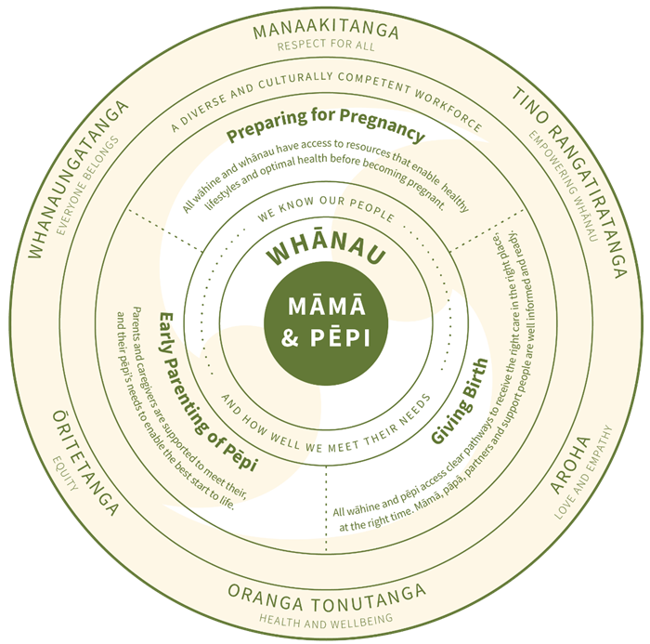  The Maternity Strategy puts māmā and pēpi at the centre of what we do and what we want to achieve. Māmā and pēpi are supported by whānau, who are the people the māmā identifies as her support network.

 |  | As members of the Women’s Health Team, we all act in alignment with the values of our maternity service at all times.
 |  | Ōritetanga (Equity)  Whanaungatanga (Everyone belongs)  Tino rangatiratanga (Empowering whānau) |  | Oranga tonutanga (Health and Wellbeing)  Aroha (Love and Empathy)
 | OUR TEAM ACCOUNTABILITY |  | You will have shared accountability for:  - Providing culturally appropriate guidance to enable māmā, pāpā/partner and support people to feel confident in making informed decisions choices about becoming parents through access to education and improved health literacy and resources.  - Assisting all wāhine and whānau to have access to adequate and culturally appropriate resources that enable healthy lifestyles and optimal health before becoming pregnant.  - Enabling māmā to confidently access the right care, in the right place and at the right time, for themselves and their unborn pēpi.  - Supporting the use of rongoā and other traditional practices within whānau as part of acknowledging the cultural diversity within our community.  - Providing appropriate pregnancy support within the community and/or tertiary setting, and birthing options that meet the needs of māmā and pēpi to receive care in the right place and at the right time.  - Contributing towards implementation of a hub and spoke model for secondary and tertiary level services to improve accessibility across Canterbury and enable timely access when this is needed.  Supporting parents and caregivers to meet their, and their pēpi’s needs to enable the best start to their life.

MY ROLE RESPONSIBILITY | The Registered Midwife is recognised as an autonomous practitioner.  Specifically, the role is responsible for:  - Working in partnership with wāhine to ensure they receive quality, evidence informed maternity care whilst they are in hospital.  - Working to the NZCOM Standards of Practice and Turanga Kaupapa www.midwife.org.nz/midwives/professional -practice/standards- of- practice/  - Assisting the DHB to meet its requirements as a maternity services provider as outlined within the maternity services specifications.  - Providing midwifery services that support the provision of primary, secondary and tertiary services within the DHB.  - Working in partnership with wāhine, LMCs and other members of the health care team to ensure maternity care plans are developed, implemented and reviewed to meet the needs of the wāhine and her pēpi during the inpatient stay.  - Providing emergency midwifery support as required and facilitate transfers to other maternity services when needed.  - Demonstrating professionalism as a midwife.  - Maintaining and developing clinical skills and professional decision making.  - Undertaking clear written and verbal communication when working with wāhine and/or colleagues.

MY CAPABILITY (INCLUDING CLINICAL CAPABILITIES) | Qualifications, experience, knowledge and skills:  Essential:  - Registered with the Midwifery Council of New Zealand.  - Has a current Annual Practising Certificate with no conditions other than MFYP, overseas midwife requirements, RTP or as agreed with Manager and Midwifery Council.  - Evidence of recent midwifery practice; or  - for recent midwifery graduates, evidence of enrolment on the Midwifery First Year of Practice Programme.  - or evidence of a Return to Practice Programme.  - Should have the ability to work rostered shifts in a multi-disciplinary team.  - An understanding of Te Tiriti o Waitangi and how it applies to the provision of health care.  - Demonstrated understanding of maternity care delivery in New Zealand.  - Demonstrated ability to work effectively within a busy environment with competing demands in keeping with their level of experience.  (Graduate, Return to Practice and Midwives new to the particular service area will need support and preceptorship particularly in secondary / tertiary maternity facilities in order that they can meet this requirement.)  - Strong commitment to women’s and children’s health.  - A commitment to the protection, promotion and support of breastfeeding.  - Good communicator, with the ability to make informed decisions that focus on providing quality maternity care for the women within our services.  - Demonstrate the ability to work both autonomously and collaboratively with other professionals.  - Ability with orientation to use IT systems used within the maternity facilities  - Excellent time management, interpersonal and organisational skills.  - Ability to be adaptable, flexible and solution focused.  Desirable:  - Innovative/creative.  - Enthusiastic.

MY RELATIONSHIPS TO NURTURE | Internal  - Midwifery and Nursing staff  - Obstetric colleagues  - Women’s Health: Allied Health Staff, Clinical Support Department, Neonatal Service Staff, Lactation Consultants, Maori Health Staff, Gynaecology Service Staff  - Maternity Quality Team  - Services supplied by the greater campus and external services e.g. supply and food services  - Support Services such as Quality, Finance, Health & Safety, People & Capability | External Partnerships  - Lead Maternity Carers and LMC Liaison  - New Zealand College of Midwives  - Oranga Tamariki

OUR WELLBEING, HEALTH AND SAFETY | At our DHB, we're committed to promoting a culture where our people's wellbeing, health and safety is at the core of everything we do. We're committed to a healthy and safe working environment to enable everyone to return home safe and well every day. We're driving for a positive, inclusive, engaging culture where our people feel safe and engaged in their work.  We know that it's important to look after yourself, in order to provide the best possible care to our community. We are all responsible for the health and safety of ourselves and each other. We need to work together to ensure wellbeing, health and safety risks do not put our people at risk of harm.

