TEAM | Maternity Service, Women’s Health
ROLE TITLE | Midwife Clinical Coach
REPORTS TO | Operational Reporting Lines: Clinical Midwife Manager, Midwife Manager and  Associate Director of Midwifery  Professional Reporting Line: Executive Director of Midwifery & Maternity Services,  Waitaha Canterbury & Te Tai o Poutini West Coast
DIRECT REPORTS | N/A
BUDGET | N/A

OUR CULTURE  THE MATERNITY STRATEGY FRAMEWORK |  | At Waitaha Canterbury, we are committed to honouring the principles of Te Tiriti o Waitangi by ensuring our partnership with Māori are at the forefront of all our conversations. We are also committed to putting people at the heart of all we do, so that we are all supported to deliver world class healthcare to our communities. This means we all behave with honesty, integrity and courage; doing the right thing by each other and our communities. We demonstrate care and concern for our own and others wellbeing. We believe that diversity and inclusion is critical to ensure we deliver the best care for our diverse communities. Therefore, we always respect and value everyone’s differences. When making decisions we consider and seek a diverse range of viewpoints especially those from minority groups.  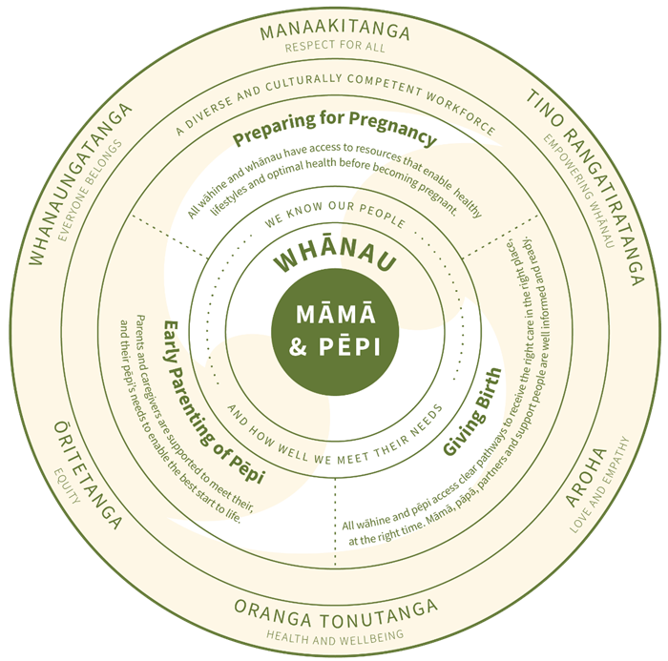  The Maternity Strategy puts māmā and pēpi at the centre of what we do and what we want to achieve. Māmā and pēpi are supported by whānau, who are the people the māmā identifies as her support network.
 |  | As a member of the Maternity Service, Women’s Health Team, you are committed to act and behave in alignment with our values at all times:
 |  | Ōritetanga (Equity)  Whanaungatanga (Everyone belongs)  Tino rangatiratanga (Empowering whānau) |  | Oranga tonutanga (Health and Wellbeing)  Aroha (Love and Empathy)
 | OUR TEAM ACCOUNTABILITY |  | You will have shared accountability for:  - Providing adequate and culturally appropriate guidance to enable māmā, pāpā/partner and support people to feel confident in making informed decisions choices about becoming parents through access to education and improved health literacy and resources.  - Assisting all wāhine and whānau to have access to adequate and culturally appropriate resources that enable healthy lifestyles and optimal health before becoming pregnant.  - Enabling māmā to confidently access the right care, in the right place and at the right time, for themselves and their unborn pēpi.  - Supporting the use of rongoā and other traditional practices within whānau as part of acknowledging the cultural diversity within our community.  - Providing appropriate pregnancy support within the community and/or tertiary setting, and birthing options that meet the needs of māmā and pēpi to receive care in the right place and at the right time.  - Contributing towards implementation of a hub and spoke model for secondary and tertiary level services to improve accessibility across Canterbury and enable timely access when this is needed.  - Supporting parents and caregivers to meet their, and their pēpi’s needs to enable the best start to their life.
 | MY PURPOSE |  | The Midwife Clinical Coach provides practical clinical education in the workplace, demonstrating effective, evidence informed and culturally safe practice. They work closely with new graduates (MFYP) and new staff to the maternity service or clinical area, midwives on the ‘Return to Practice’ (RTP) Programme to support their transition to confident practitioners in the clinical setting and midwives who need to refresh their clincial skills or work towards their Performance Improvement Plan (PIP). The Midwife Clinical Coach works in a supernumeracy capaicty and is responsible for promoting a learning environment within the clinical setting that encourages and supports development of midwives’ clinical skills and knowledge, reducing staff stress and therefore enabling in staff retention.
 | MY ROLE RESPONSIBILITY |  | The Midwife Clinical Coach is recognised as an autonomous practitioner. Specifically, the role is responsible for:  Clinical coaching:  - Takes a supportive role in enabling and motivating midwives to develop skills and confidence and is available for clinical support and advice in all areas of midwifery practice.  - Shares knowledge and skills and provides advice that is consistent with organisational core values and polices and guidelines.  - Works with midwives to identify and support the achievement of their individual clinical learning needs and develops a support plan with the staff member and their manager.  - Role models clinical excellence and culturally safe midwifery practice.  - Is a recognised clinical resource for all staff but particularly those new to the clinical area.  - Demonstrates adult learning principles and provides coaching in a positive and supportive manner.  - Works in a supernumerary capacity to ensure that adequate time and resource is able to meet the needs of learners.  - Works closely with the tertiary education providers to develop relationships with students who will become new graduate midwives.  - Assists in the development of the midwifery new graduate programme and provides practical support for new graduate midwives including one to one clinical support in the workplace.  - Orientates new staff and provides one to one clinical support in the workplace during the orientation period.  - Provides orientation and clinical support to midwives who are new maternity access holders  - Identifies Māori and Pacific midwives who may require additional cultural support and connects them with this support and with peers  - Identifies and leads programmes that can improve the transition of new graduates and new midwives into confident practitioners in the clinical setting  - Coaches midwives in developing critical thinking skills.  Midwifery Council requirements:  - The Midwife Clinical Coach role will not have a managerial or reporting relationship in relation to any of the midwives completing a return to practice programme. If that is unavoidable, the organisation undertakes to inform the Council immediately so that other arrangements may be made in respect of any midwives with whom that managerial or reporting relationship exists.  - The Midwife Clinical Coach will sign an agreement with the Council outlining the responsibilities in respect of their role as supervisor to midwives undertaking the Return to practice programme.  Professional development:  - Leads professional conduct by example.  - Practises in accordance with legal, ethical, culturally safe and professional standards.  - Maintains and develops own expertise and knowledge in midwifery practise through continuing professional development.  - Pro-actively participates in own performance development and review.  - Develops and sustains productive working relationships with the multi-disciplinary team to facilitate best practice.  Continuous quality improvement and risk management:  - Demonstrate clinical leadership in identifying and proposing quality improvement.  - Encourage midwives to attend and/or participate in maternity specific case review meetings.  - Provides feedback to Midwifery Educator about possible areas for education sessions.  Statutory and Te Tiriti o Waitangi obligations:  - Demonstrates culturally safe practice, upholds Te Tiriti o Waitangi, and demonstrates commitment to Pae Ora.  - Contributes to the professional and political integrity of the organisation by carrying out all functions in compliance of the Te Tiriti o Waitangi.  - Works to minimize health disparity for Māori and enhance equity of access and outcome.  - Shows sensitivity to cultural complexity in the workforce and population.  Contribute to a safe and healthy workplace:  - Follow and comply with H&S policies & processes, and apply them to own work activities, including use of/wearing Personal Protective Equipment as required.  - Participate in activities directed at preventing harm & promoting well-being in the workplace.  - Identify, report and self-manage hazards where appropriate.  - Early and accurate reporting of incidents at work and raise issues of concern when identified.

MY CAPABILITY (INCLUDING CLINICAL CAPABILITIES) | Qualifications, experience, knowledge and skills:  Midwifery Council specified:  - Be a registered midwife.  - Have a minimum of five years’ post-qualifying clinical experience.  - Hold a current practising certificate.  - Have no conditions on their scope of practice or practising certificate.  - Have never been the subject of any adverse finding of any professional disciplinary body.  - Demonstrate clinical and cultural competence to a high standard.  - Be fully engaged in the Midwifery Council Recertification Programme.  Experience and skills:  - Skills, knowledge and ability to provide education and coaching.  - Ability to demonstrate clinical leadership, and maintain contemporaneous evidence informed practice.  - Confidence using Microsoft office products.  - Experience in adult learning principles and practice.  - Knowledge of programme development.  - Ability to plan, implement and evaluate an individual coaching plan.  - Evidence of strong commitment to quality improvement.  - Demonstrated confident collaborative approach, enhancing the capability and contribution of the team.  Personal attributes:  - Mature, positive, proactive and enthusiastic attitude.  - Ability to work under own direction without oversight.  - NZCOM preceptor or mentor training course.  - Completed or participating in postgraduate education.  - Committed to own professional and personal development.  - Receives and processes constructive feedback related to own performance.  - Kind, empathic and committed to the learning needs of others.  - Seeks out opportunities to support others in achieving goals.  - Strong teamwork, collaboration and inclusive of colleagues.  - Is able to manage conflict constructively.  - Recognises and respects individual differences.  - Develops positive working relationships.  - Upholds confidentiality, behaves with integrity and discretion.  - Makes effective decisions within appropriate timeframes and levels of responsibility.  - Escalates issues appropriately and seeks assistance when needed.  - Demonstrates strong written and verbal communication skills.  - Communicates without engendering conflict.  - Articulate, good presentation skills.

MY RELATIONSHIPS TO NURTURE | Internal  - Midwifery staff  - Midwife educator(s)  - MQSP coordinator  - Obstetric staff  - Neonatal staff  - Theatre staff  - Learning and development staff  - Quality staff  - Other hospital staff midwives refer to | External Partnerships  - Lead Maternity Carers  - Midwifery Council  - NZCOM  - Educational institutions (as required)

OUR WELLBEING, HEALTH AND SAFETY | At Waitaha Canterbury, we're committed to promoting a culture where our people's wellbeing, health and safety is at the core of everything we do. We're committed to a healthy and safe working environment to enable everyone to return home safe and well every day. We're driving for a positive, inclusive, engaging culture where our people feel safe and engaged in their work.  We know that it's important to look after yourself, in order to provide the best possible care to our community. We are all responsible for the health and safety of ourselves and each other. We need to work together to ensure wellbeing, health and safety risks do not put our people at risk of harm.

