TEAM | Allied Health
ROLE TITLE | Clinical Coordinator Critical Care
REPORTS TO  DIRECT REPORTS  SALARY BANDING | Clinical Manager of your profession  This role has delegated people management responsibilities  Band B degree-based Allied, Public Health & Technical Pay Scale 5.2

OUR CULTURE  OUR TEAM ACCOUNTABILITY | At Waitaha Canterbury and Te Tai o Poutini West Coast, we are committed to honouring the Te Tiriti o Waitangi and its principles by ensuring our partnership with Māori are at the forefront of all our conversations. We are also committed to putting people at the heart of all we do, so that we are all supported to deliver world class healthcare to our communities. This means we all behave with honesty, integrity and courage; doing the right thing by each other and our communities. We demonstrate care and concern for our own and others wellbeing. We believe that diversity and inclusion is critical to ensure we deliver the best care for our diverse communities. Therefore, we always respect and value everyone’s differences. When making decisions we consider and seek a diverse range of viewpoints especially those from minority groups.  As a member of the Allied Health Team, you will actively support and enable the Canterbury and the West Coast Waitaha Canterbury and Te Tai o Poutini West Coasts’ Strategic Direction and the aligned Allied Health Strategic Plan, as a result this role has shared accountability for:  - Growth and development of a more capable and diverse Kaiāwhina workforce aligned with current Waitaha Canterbury and Te Tai o Poutini West Coast healthcare delivery models.  - Effective engagement and support of growth, success and development activity, including creating opportunities for other Allied Health professional group to build capacity and capability beyond individual professions and clinical skill.  - Support and optimisation of professional development and clinical education through inter-professional learning, positive practice and a growth culture and behaviours to enhance inter-professional and person-centred models of care.  - Active partnership, participation and empowerment of our tāngata whaiora and their whānau through effective use of prevention and early intervention and enablement strategies.  - Commitment and participation in system and service improvement and transformation to enhance equity and outcomes of the tāngata and their whānau.  - Encouragement, facilitation and utilisation of on-going feedback, data and systematic exploration and implementation of universal and targeted health care support that is underpinned by evidence and best practice, as well as cultural input and co-design process.  - Implementation and utilisation of data and technology to plan, evaluate and modify the way we deliver efficient care that is timely and responsive and empowering our tāngata whaiora to take greater responsibility for their wellbeing.  - Support, encouragement, promotion and celebration of Allied Health research, innovation and improvement across all professional disciplines within the Canterbury and the West Coast systems.  - Support and participation in clinical governance and quality improvement activities to increase collaboration, reduce and eliminate waste.

MY ROLE RESPONSIBILITY | As per South Island Allied Health Career Framework, Clinical Coordinator coordinates clinical activities within the team/service on a day-to-day basis as delegated by the line manager. This role will also be required to provide direct clinical care as appropriate to the needs of the service area.  Types of roles may include central coordination and a strong understanding of service specifications, clinical roles of MDT and clinical pathways.  Majority of your time will be spent within the Clinical Practice pillar (this may be direct or non-direct patient/client intervention), though the amount of time within this pillar and the other pillars will be dependent on service and role requirements. Your time will also be spent in the Leadership & Management and Service Improvement pillars.  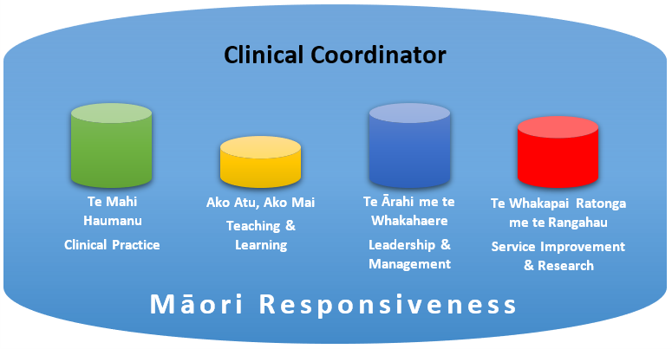  Specifically, the role is responsible for (Include if applicable to the role):  - Management of clinical case load and direct delivery of a health care service, including assessment of clinical care needs (including diagnosing), development and implementation of clinical care/interventions or therapy programmes, as well as the provision of specialised clinical or non-clinical advice or information in relation to the care or education of tāngata whaiora.  - Key contact for Critical Care team for Allied Health related communications.  - The day-to-day coordination, of Allied Health Critical care team, including capacity planning and co-ordination, assist profession specific team leaders in placement or allocation of AHP staff or Assistants or students.  - Contribute to success and development and performance management processes when required.  - Coordinate Allied Health quality improvement initiatives.  - Professional leadership and supervision of clinical activity and practice, through provision of expert clinical advice, consultation and support to clinical practitioners, while working within professional or occupational policies and be accountable for own professional actions.  - Setting targets and goals for a department, division or service and supporting corresponding informatics processes, such as data gathering and reporting (Care Capacity Demand Management (CCDM), KPIs, incident management).  - Be involved in service and policy development including support to staff to participate in and contribute to quality improvement activities. This includes determining how certain national, regional or organisational policies, legislation and initiatives should be put into practice.  - Teaching or educating staff both within the Allied Health profession and inter-disciplinary, including clinical or non-clinical skills development in one on one or group setting, as well as undertaking workplace assessments (e.g. assessing students or NZQA assessments for assistants, clinical competencies etc.), including support of recruitment and workforce development components.  - Reviewing performance metrics and implementing relevant governance/quality improvement structures within the team.  - Effectively managing own time and time of others, management of rosters, meetings, projects, provision of services, formal programmes of education or training as well as long term strategic planning, with potential requirement to support profession-related conferences.  - Day to day use of general and specialty equipment, stock control, as well as training other staff and tāngata whaiora on safe equipment use practices and maintenance.  - Carrying out clinical / non-clinical audits, initiating, developing, co-ordinating and/or implementing research and development programmes and activities, as well as carrying out research and development work aligned with these or other programmes within the team, service or department.  - Driving, supporting and/or facilitating projects and project related work, participation in steering groups and consultation processes, e.g. Career force training (Calderdale Framework)  - Performing other duties considered to be within the scope of this role as agreed by you and your manager.

MY CAPABILITY | To be effective and succeed in this role it is expected the person will have proven capabilities against the Leads People leadership focus:  A person with this leadership focus is someone that either has direct line management responsibilities for team members or coordinates or supervises others. Their core focus is to support, enable and develop our people.  - Cultural Responsiveness – works proactively with Māori to uphold the principles of Te Tiriti o Waitangi and implements the Waitaha Canterbury And Te Tai o Poutini West Coast vision of ensuring equitable outcomes for Māori.  - Enhancing People Performance - Improve performance and bring out the best in people; to deliver high quality results for patients.  - Enhancing Team Performance - Build cohesive and high performing teams; to deliver collective results that are more than the sum of individual eﬀorts.  - Achieving Through Others - Eﬀectively delegate and maintain oversight of work responsibilities; to leverage the capability of people to deliver outcomes for the people we care for.  - Identifying and Developing Talent - Encourage and support diversity and build the people capability required to deliver outcomes.  - Self-Aware - Understands their impact on others and strengthen personal capability over time.  - Engaging others - Connect with people; to build trust and become a leader that people want to work with and for.  - Resilient and Adaptive - Show composure, resolve, and a sense of perspective when the going gets tough. Helps others maintain optimism and focus.  - Honest and Courageous - Delivers clear messages and makes decisions in a timely manner; to advance the longer-term best interests and drive improvement in processes, equity and outcomes for the people, communities and whanau we care for and serve.  Clinical/Technical skills (Include if applicable to the role)  - Computer and typing skills  - Experience in using Patient Management Systems  - Training and experience using the following equipment or tools (e.g.  - Training and experience in manual handling  - Manual therapy experience and skills  - Mandatory training as required for the role  Essential:  - Minimum a Bachelor degree in the relevant profession.  - NZ Registration with the relevant professional body.  - A current Annual Practicing Certificate with the relevant professional body and scope of practice.  - Minimum 5 years of clinical work experience in the relevant field of specialty and environment.  - Experience with clinical teaching/supervision, training and development of staff  - Experience making judgements in complex situations where there is incomplete information or solutions are not obvious.  - Experience in people leadership and/or management  - Experience in quality / service improvement activities  - Knowledge of NZ Health & Disability sector standards and the Privacy Act within a health context  Desirable (Include if applicable to the role)):  - Post-graduate certificate.  - Membership with the relevant Professional Association  - Full Drivers Licence

MY RELATIONSHIPS TO NURTURE | Internal  - Service, Clinical and Case Managers and Leaders  - Directors of Allied Health  - New entry, Professional, Advanced, Expert and Consultant Allied Health Professionals  - Allied Health Educators, Coordinators and Professional Leaders  - Administrators  - Nursing and Medical professionals and leaders  - Union Delegates | External  - Tāngata whaiora and their whānau  - External community agencies, government agencies and healthcare providers  - Union Partners  - Local Iwi

OUR WELLBEING, HEALTH AND SAFETY | At Waitaha Canterbury and Te Tai o Poutini West Coast, we're committed to promoting a culture where our people's wellbeing, health and safety is at the core of everything we do. We're committed to a healthy and safe working environment to enable everyone to return home safe and well every day. We're driving for a positive, inclusive, engaging culture where our people feel safe and engaged in their work.  We know that it's really important to look after yourself, in order to provide the best possible care to our community. We are all responsible for the health and safety of ourselves and each other. We need to work together to ensure wellbeing, health and safety risks do not put our people at risk of harm.

